**Lumière** - **Cosmetics Platform**

**Group 1:** S Snekha (TL), Joanisa Hasan, Sushree Pallabi Nayak, Indukuri Divya Sai

## **Project Overview**

The **Cosmetics Store Microservices Platform** is a full-stack e-commerce solution designed to manage makeup product listings, customer orders, feedback, and administrative operations. The platform is built with a microservices architecture that ensures modularity, scalability, and independent deployment. It uses a combination of **Spring Boot**, **Node.js**, and **Python** for backend services, along with **React** for the frontend interface.

Project Glossary:

* Customer and admin authentication systems
* Product management with feedback and reviews
* Order placement and tracking
* Skin-type-based product recommendation
* Feedback Management
* Real-time service communication via **Apache Kafka**
* Service discovery using **Eureka** and a custom **Node-based registry**
* API documentation using **Swagger**
* Dockerized deployment with docker-compose
* Logging and error boundary handling for robust fault tolerance

## **How to Run the Project (Using .bat File)**

To simplify startup, all services can be initialized using a Windows batch file.

**Steps:**

1. **Navigate to the Project Directory**:
2. **Run the Startup Script**:

run_all.bat

This .bat file internally:

* Initializes Eureka and Node-based service registries
* Starts Kafka and Zookeeper
* Boots up all backend microservices
* Launches the frontend app in the browser

**Architecture Diagram:**

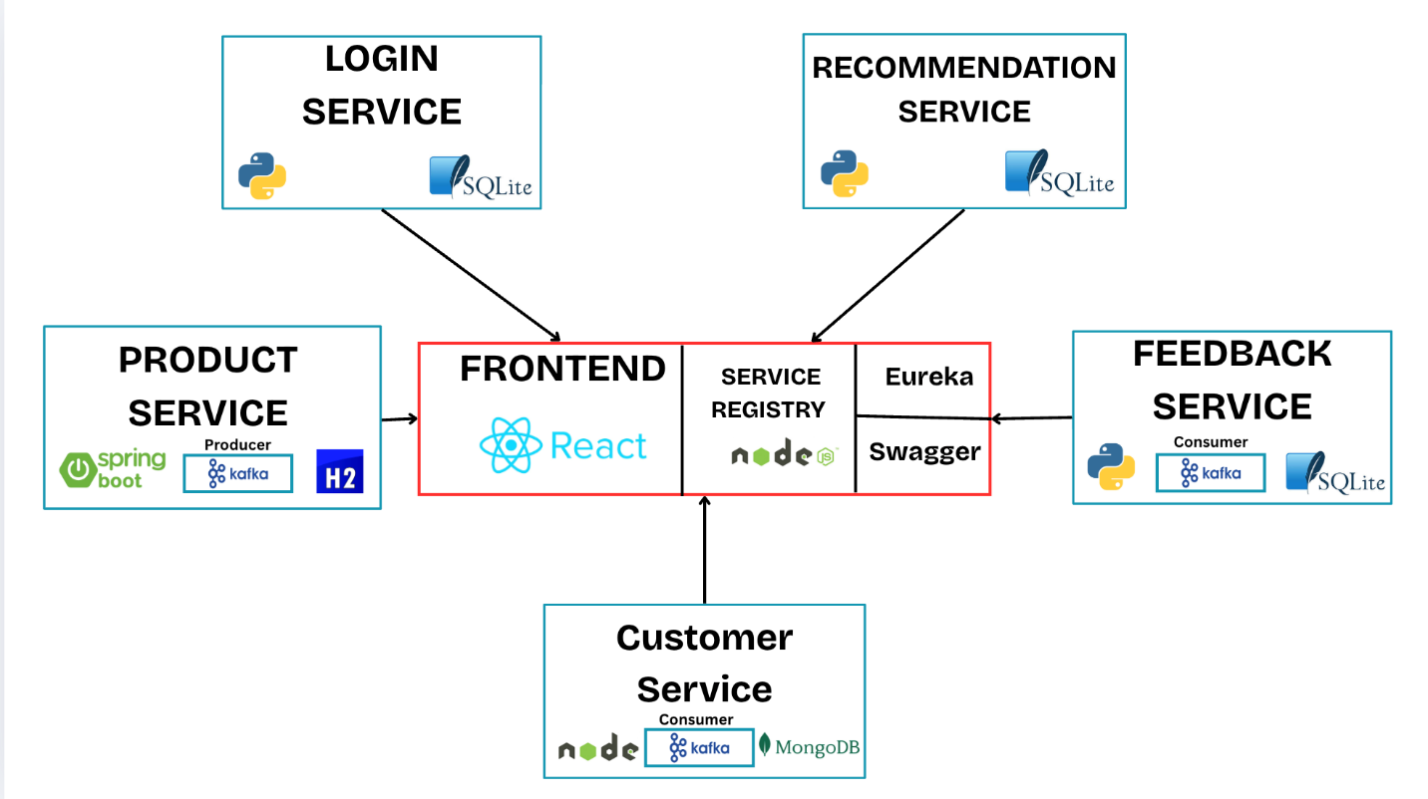

## **Product Service Documentation**

Contributor: **S Snekha**

### **Overview**

The **Product Service** is a **Spring Boot-based RESTful service** responsible for handling operations related to cosmetic products, including adding, updating, deleting, and retrieving product information. This service connects to a relational database, stores product data, and provides various API routes to interact with the products.

### **Database Information and Schema (H2 Database)**

The **Product Service** uses an in-memory **H2 Database** for managing product data. The following schema is used to store and retrieve products:

**Product Table (cosmetic_products)**

|  |  |  |
| --- | --- | --- |
| **Column Name** | **Data Type** | **Constraints** |
| id | long | Primary Key, Auto-increment |
| title | String | Not Null |
| brand | String | Not Null |
| category | String | Not Null |
| description | String | Optional |
| price | double | Not Null |
| quantity | int | Not Null |
| image_url | String | Optional |
| rating | double | Not Null |
| suitable_for_skin_type | String | Optional |
| gender_target | String | Optional |

### **REST API Routes**

The **Product Service** exposes the following REST API routes to interact with the products:

#### **1. Add a New Product**

* **POST** /api/cosmetics/add
* **Request Body**:

**{**  
 **"title": "Moisturizing Cream",**  
 **"brand": "GlowSkin",**  
 **"category": "Skincare",**  
 **"description": "Hydrating cream for dry skin.",**  
 **"price": 25.99,**  
 **"quantity": 100,**  
 **"imageUrl": "**[**http://example.com/image.jpg**](https://urldefense.com/v3/__http://example.com/image.jpg__;!!Nyu6ZXf5!sWkJB9Emwy60PyGnph4kv8HUPF7TYjhX1wscRKhA3KnL84pguTDF36VMAMGh3-qmvm7Keiol97DkP_f2vkh_rQ2L$)**",**  
 **"rating": 4.5,**  
 **"skinType": "Dry",**  
 **"gender": "Unisex"**  
**}**

* **Response**:
  + **Status**: 201 Created
  + **Response Body**:

**{**  
 **"id": 1,**  
 **"title": "Moisturizing Cream",**  
 **"brand": "GlowSkin",**  
 **"category": "Skincare",**  
 **"price": 25.99,**  
 **"quantity": 100,**  
 **"imageUrl": "**[**http://example.com/image.jpg**](https://urldefense.com/v3/__http://example.com/image.jpg__;!!Nyu6ZXf5!sWkJB9Emwy60PyGnph4kv8HUPF7TYjhX1wscRKhA3KnL84pguTDF36VMAMGh3-qmvm7Keiol97DkP_f2vkh_rQ2L$)**",**  
 **"rating": 4.5,**  
 **"skinType": "Dry",**  
 **"gender": "Unisex"**  
**}**

#### **2. Get All Products**

* **GET** /api/cosmetics/all
* **Response**:
  + **Status**: 200 OK
  + **Response Body**:

**[**  
 **{**  
 **"id": 1,**  
 **"title": "Moisturizing Cream",**  
 **"brand": "GlowSkin",**  
 **"category": "Skincare",**  
 **"price": 25.99,**  
 **"quantity": 100,**  
 **"imageUrl": "**[**http://example.com/image.jpg**](https://urldefense.com/v3/__http://example.com/image.jpg__;!!Nyu6ZXf5!sWkJB9Emwy60PyGnph4kv8HUPF7TYjhX1wscRKhA3KnL84pguTDF36VMAMGh3-qmvm7Keiol97DkP_f2vkh_rQ2L$)**",**  
 **"rating": 4.5,**  
 **"skinType": "Dry",**  
 **"gender": "Unisex"**  
 **},**  
 **{**  
 **"id": 2,**  
 **"title": "Lipstick",**  
 **"brand": "BeautyCo",**  
 **"category": "Makeup",**  
 **"price": 15.99,**  
 **"quantity": 50,**  
 **"imageUrl": "**[**http://example.com/lipstick.jpg**](https://urldefense.com/v3/__http://example.com/lipstick.jpg__;!!Nyu6ZXf5!sWkJB9Emwy60PyGnph4kv8HUPF7TYjhX1wscRKhA3KnL84pguTDF36VMAMGh3-qmvm7Keiol97DkP_f2vucncenR$)**",**  
 **"rating": 4.2,**  
 **"skinType": "All",**  
 **"gender": "Female"**  
 **}**  
**]**

#### **3. Get Product by ID**

* **GET** /api/cosmetics/{id}
* **Example Request**: /api/cosmetics/1
* **Response**:
  + **Status**: 200 OK (if product exists)
  + **Response Body**:

**{**  
 **"id": 1,**  
 **"title": "Moisturizing Cream",**  
 **"brand": "GlowSkin",**  
 **"category": "Skincare",**  
 **"price": 25.99,**  
 **"quantity": 100,**  
 **"imageUrl": "**[**http://example.com/image.jpg**](https://urldefense.com/v3/__http://example.com/image.jpg__;!!Nyu6ZXf5!sWkJB9Emwy60PyGnph4kv8HUPF7TYjhX1wscRKhA3KnL84pguTDF36VMAMGh3-qmvm7Keiol97DkP_f2vkh_rQ2L$)**",**  
 **"rating": 4.5,**  
 **"skinType": "Dry",**  
 **"gender": "Unisex"**  
**}**

* **Status**: 404 Not Found (if product does not exist)

#### **4. Search Products by Title or Brand**

* **GET** /api/cosmetics/search
* **Request Parameters**:
  + title (optional)
  + brand (optional)
* **Example Request**: /api/cosmetics/search?title=Moisturizing Cream
* **Response**:
  + **Status**: 200 OK
  + **Response Body**:

**[**  
 **{**  
 **"id": 1,**  
 **"title": "Moisturizing Cream",**  
 **"brand": "GlowSkin",**  
 **"category": "Skincare",**  
 **"price": 25.99,**  
 **"quantity": 100,**  
 **"imageUrl": "**[**http://example.com/image.jpg**](https://urldefense.com/v3/__http://example.com/image.jpg__;!!Nyu6ZXf5!sWkJB9Emwy60PyGnph4kv8HUPF7TYjhX1wscRKhA3KnL84pguTDF36VMAMGh3-qmvm7Keiol97DkP_f2vkh_rQ2L$)**",**  
 **"rating": 4.5,**  
 **"skinType": "Dry",**  
 **"gender": "Unisex"**  
 **}**  
**]**

#### **5. Filter Products by Category**

* **GET** /api/cosmetics/category/{category}
* **Example Request**: /api/cosmetics/category/Skincare
* **Response**:
  + **Status**: 200 OK
  + **Response Body**:

**[**  
 **{**  
 **"id": 1,**  
 **"title": "Moisturizing Cream",**  
 **"brand": "GlowSkin",**  
 **"category": "Skincare",**  
 **"price": 25.99,**  
 **"quantity": 100,**  
 **"imageUrl": "**[**http://example.com/image.jpg**](https://urldefense.com/v3/__http://example.com/image.jpg__;!!Nyu6ZXf5!sWkJB9Emwy60PyGnph4kv8HUPF7TYjhX1wscRKhA3KnL84pguTDF36VMAMGh3-qmvm7Keiol97DkP_f2vkh_rQ2L$)**",**  
 **"rating": 4.5,**  
 **"skinType": "Dry",**  
 **"gender": "Unisex"**  
 **}**  
**]**

#### **6. Update Product**

* **PUT** /api/cosmetics/update/{id}
* **Request Body**:

**{**  
 **"title": "Updated Moisturizing Cream",**  
 **"brand": "GlowSkin",**  
 **"category": "Skincare",**  
 **"description": "Updated description.",**  
 **"price": 27.99,**  
 **"quantity": 150,**  
 **"imageUrl": "**[**http://example.com/updated_image.jpg**](https://urldefense.com/v3/__http://example.com/updated_image.jpg__;!!Nyu6ZXf5!sWkJB9Emwy60PyGnph4kv8HUPF7TYjhX1wscRKhA3KnL84pguTDF36VMAMGh3-qmvm7Keiol97DkP_f2vg9GnurI$)**",**  
 **"rating": 4.8,**  
 **"skinType": "All",**  
 **"gender": "Unisex"**  
**}**

* **Response**:
  + **Status**: 200 OK
  + **Response Body**:

**{**  
 **"id": 1,**  
 **"title": "Updated Moisturizing Cream",**  
 **"brand": "GlowSkin",**  
 **"category": "Skincare",**  
 **"price": 27.99,**  
 **"quantity": 150,**  
 **"imageUrl": "**[**http://example.com/updated_image.jpg**](https://urldefense.com/v3/__http://example.com/updated_image.jpg__;!!Nyu6ZXf5!sWkJB9Emwy60PyGnph4kv8HUPF7TYjhX1wscRKhA3KnL84pguTDF36VMAMGh3-qmvm7Keiol97DkP_f2vg9GnurI$)**",**  
 **"rating": 4.8,**  
 **"skinType": "All",**  
 **"gender": "Unisex"**  
**}**

* **Status**: 404 Not Found (if product not found)

#### **7. Delete Product**

* **DELETE** /api/cosmetics/delete/{id}
* **Example Request**: /api/cosmetics/delete/1
* **Response**:
  + **Status**: 204 No Content (if product is deleted successfully)
  + **Status**: 404 Not Found (if product not found)

#### **8. Delete All Products**

* **DELETE** /api/cosmetics/delete-all
* **Response**:
  + **Status**: 204 No Content (if all products are deleted)

#### **9. Filter Products by Price or Rating**

* **GET** /api/cosmetics/filter
* **Request Parameters**:
  + minPrice (optional)
  + maxPrice (optional)
  + minRating (optional)
  + maxRating (optional)
* **Example Request**: /api/cosmetics/filter?minPrice=10&maxPrice=30
* **Response**:
  + **Status**: 200 OK
  + **Response Body**:

**[**  
 **{**  
 **"id": 1,**  
 **"title": "Moisturizing Cream",**  
 **"brand": "GlowSkin",**  
 **"category": "Skincare",**  
 **"price": 25.99,**  
 **"quantity": 100,**  
 **"imageUrl": "**[**http://example.com/image.jpg**](https://urldefense.com/v3/__http://example.com/image.jpg__;!!Nyu6ZXf5!sWkJB9Emwy60PyGnph4kv8HUPF7TYjhX1wscRKhA3KnL84pguTDF36VMAMGh3-qmvm7Keiol97DkP_f2vkh_rQ2L$)**",**  
 **"rating": 4.5,**  
 **"skinType": "Dry",**  
 **"gender": "Unisex"**  
 **}**  
**]**

#### **10. Patch Product**

* **PATCH** /api/cosmetics/patch/{id}
* **Request Body** (Partial Update Example):

**{**  
 **"price": 29.99,**  
 **"quantity": 200**  
**}**

* **Response**:
  + **Status**: 200 OK
  + **Response Body**:

**{**  
 **"id": 1,**  
 **"title": "Moisturizing Cream",**  
 **"brand": "GlowSkin",**  
 **"category": "Skincare",**  
 **"price": 29.99,**  
 **"quantity": 200,**  
 **"imageUrl": "**[**http://example.com/image.jpg**](https://urldefense.com/v3/__http://example.com/image.jpg__;!!Nyu6ZXf5!sWkJB9Emwy60PyGnph4kv8HUPF7TYjhX1wscRKhA3KnL84pguTDF36VMAMGh3-qmvm7Keiol97DkP_f2vkh_rQ2L$)**",**  
 **"rating": 4.5,**  
 **"skinType": "Dry",**  
 **"gender": "Unisex"**  
**}**  
  
**Frontend Pages**

#### **1. Add Product Page**

This page will allow admins to add a new product to the database. The form will collect information such as title, brand, category, description, price, quantity, image URL, rating, skin type, and gender.

#### **2. Update Product Page**

This page will allow admins to update an existing product. Admins can modify any product field, such as price, quantity, description, or image URL.

#### **3. Patch Product Page**

This page will allow admins to partially update a product by providing a list of fields to update. The page should allow modifying specific attributes like price or quantity.

#### **4. Product List for Customers**

This page will display all available products for customers, showing product details like title, brand, category, price, and rating.

**Functionality:**

* Clicking on a product will open the **Product Details** page.

#### **5. Product List for Admin**

This page will show all products and allow admins to:

* **Add** new products (Redirects to the Add Product page).
* **Delete** a product by clicking a delete button next to each product.
* **Patch** a product by clicking a patch button next to each product, which opens the Patch Product page.

#### **6. Product Details Page**

This page will display detailed information for a product fetched by its ID.

**Output Screenshots:**

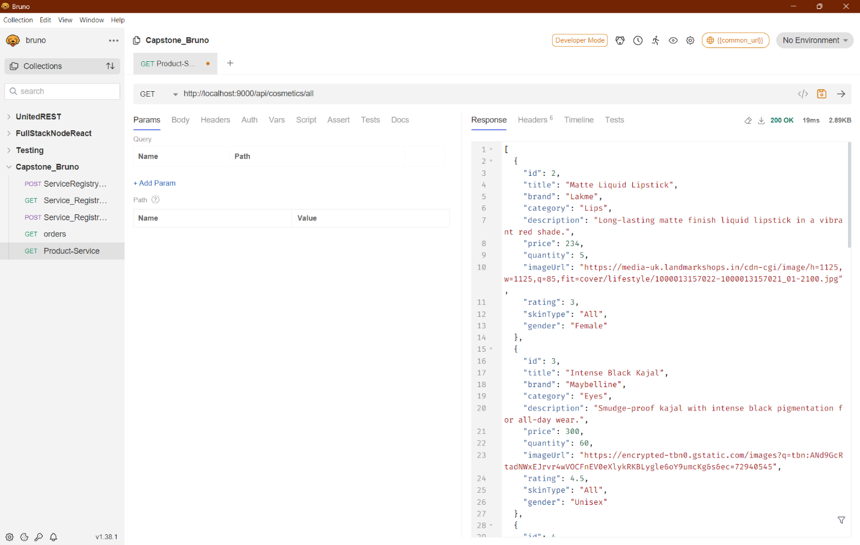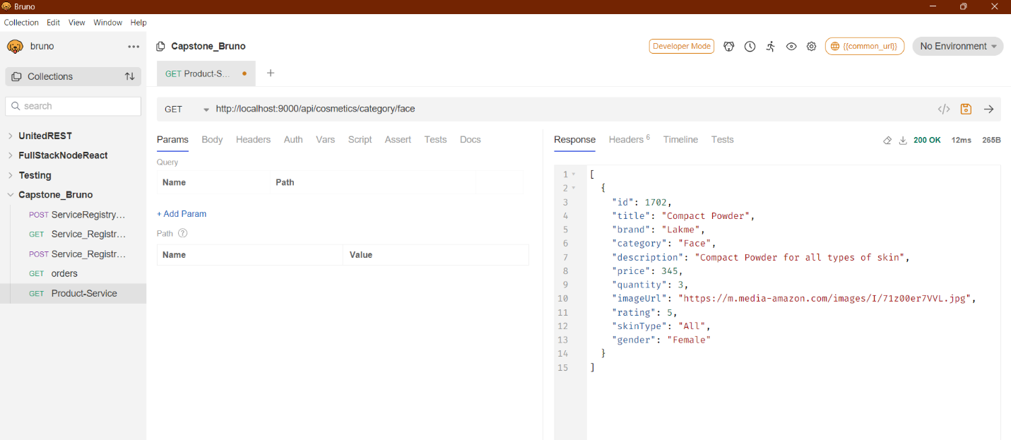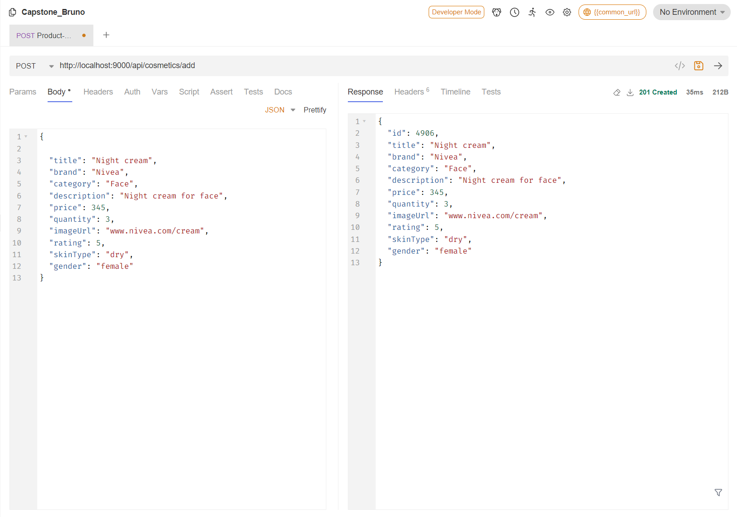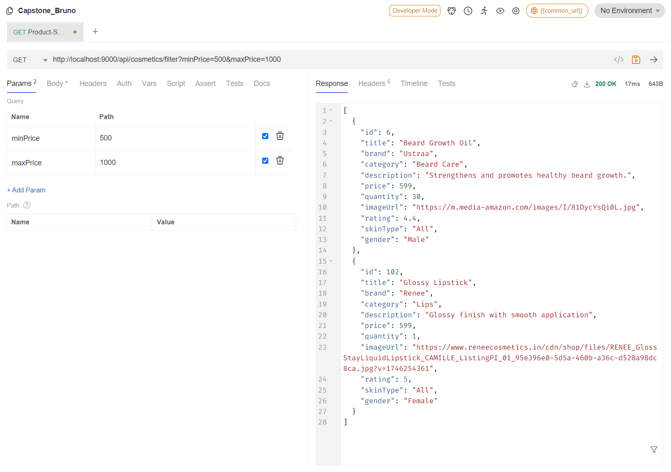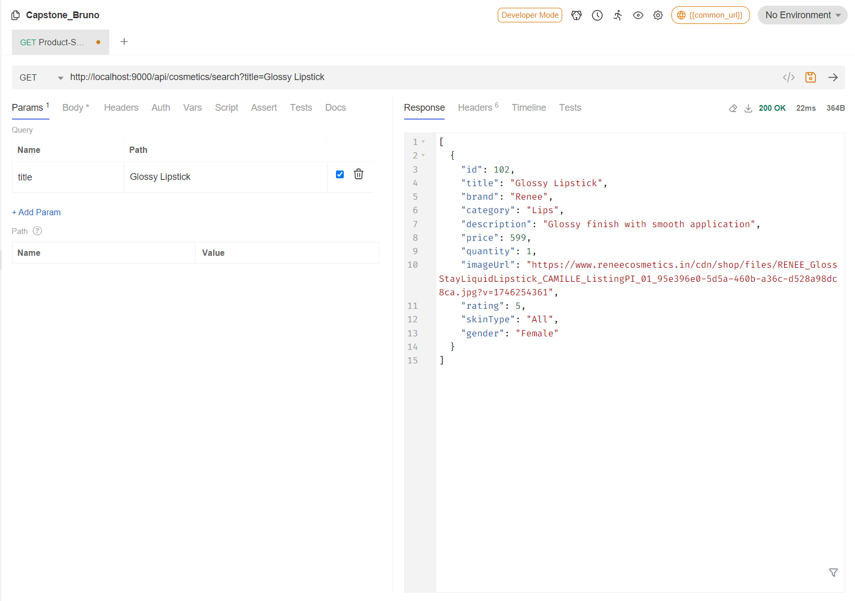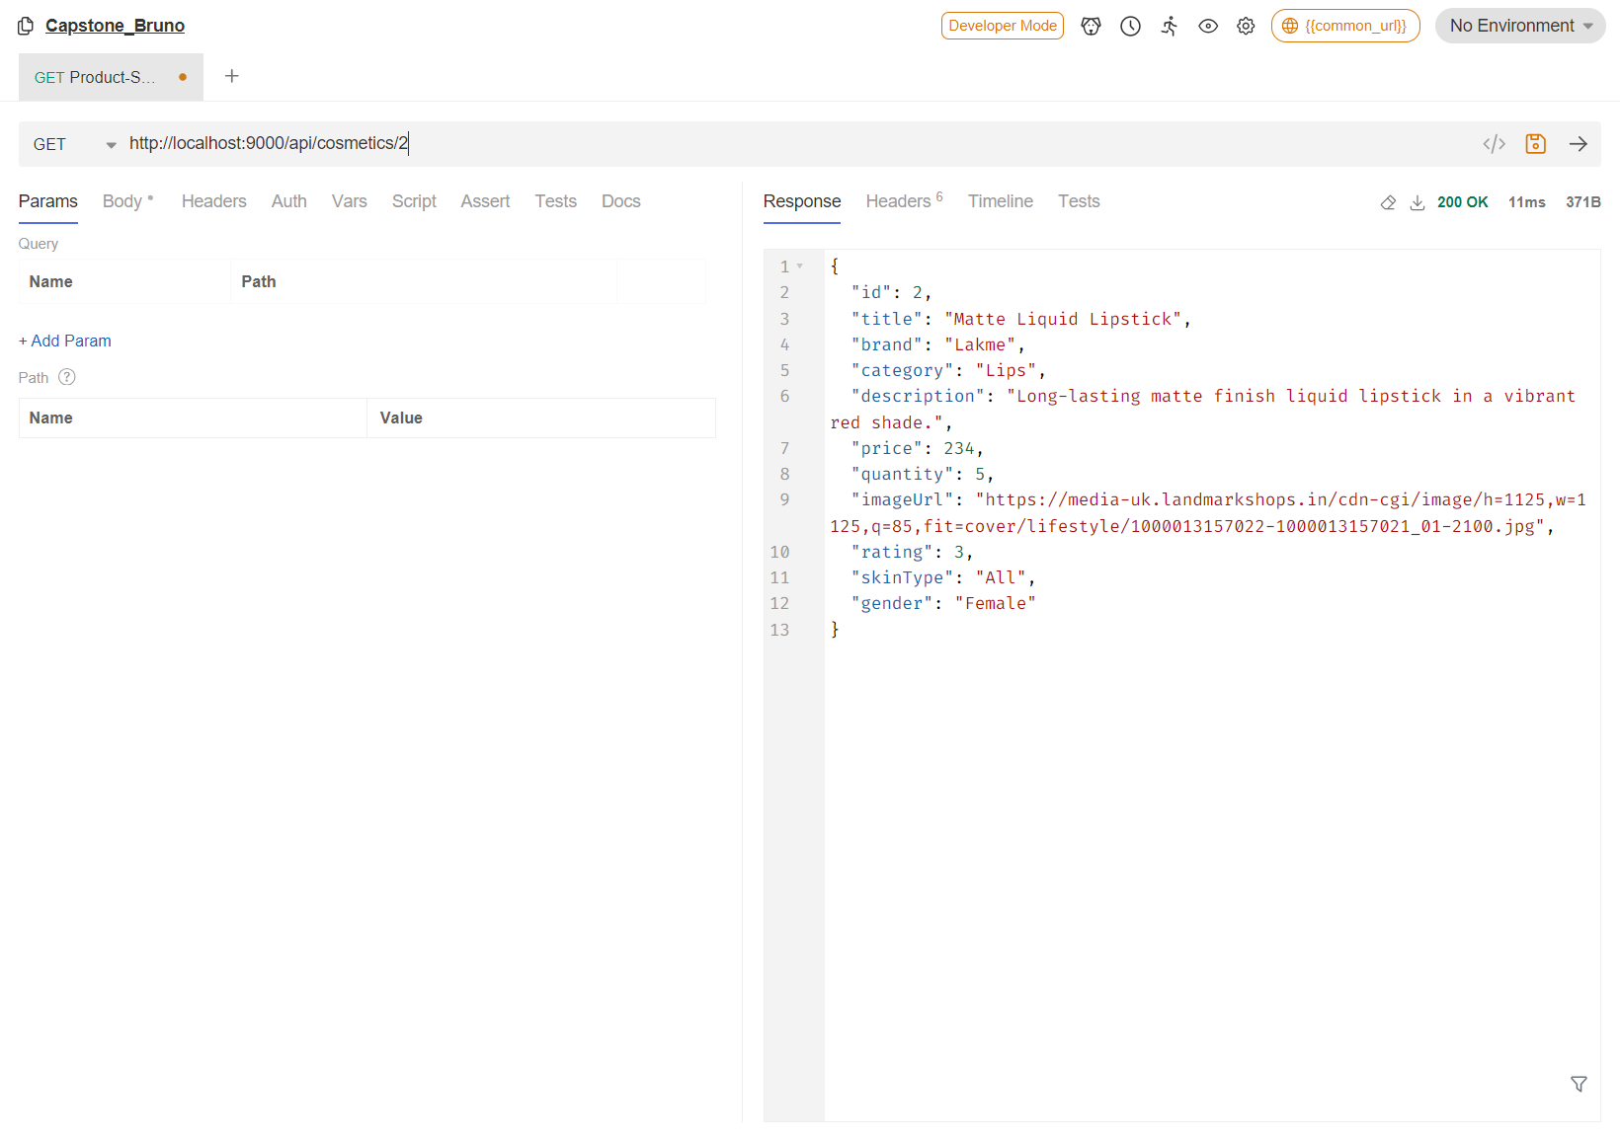

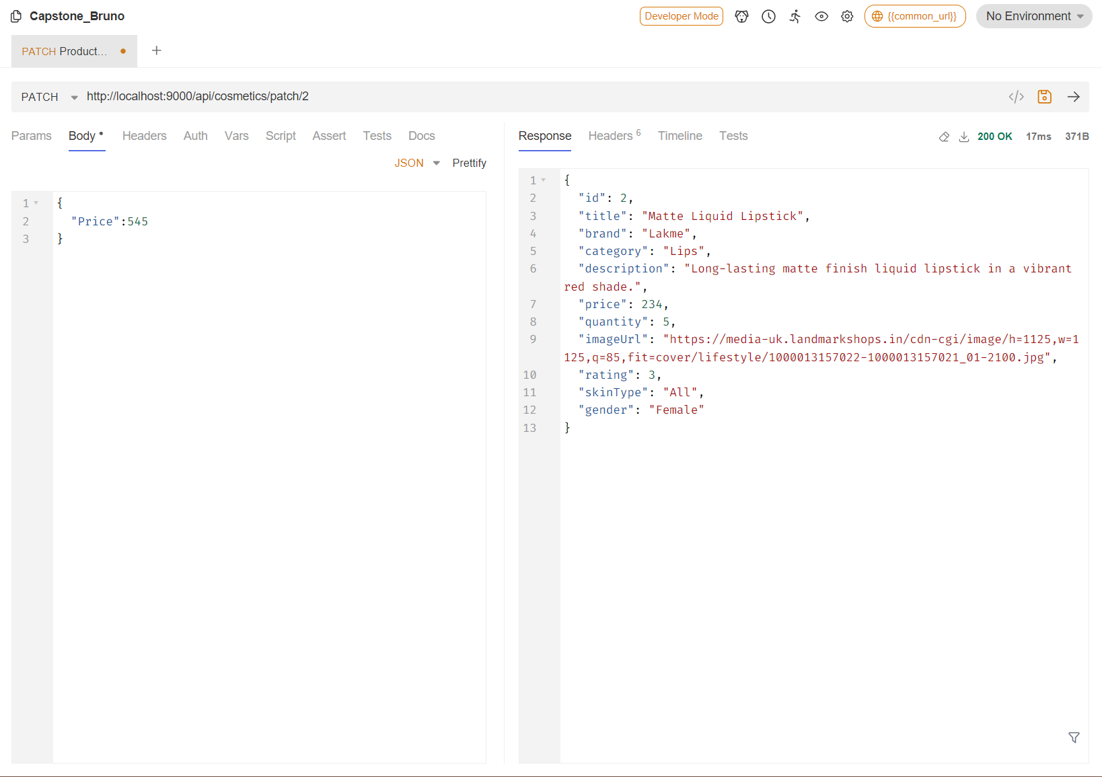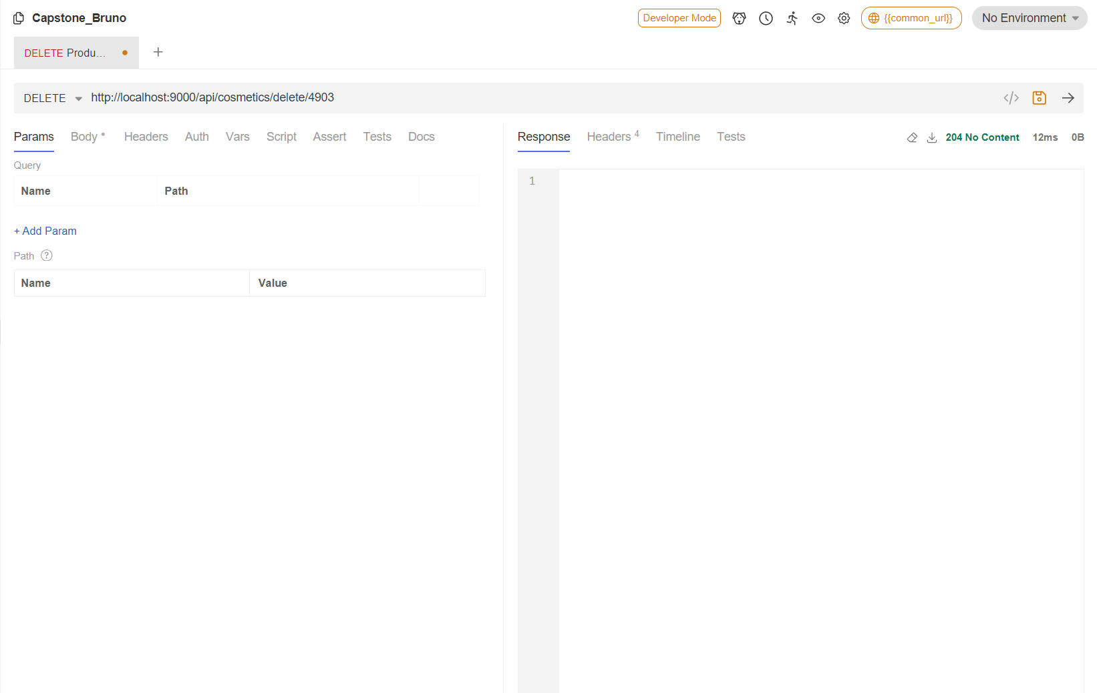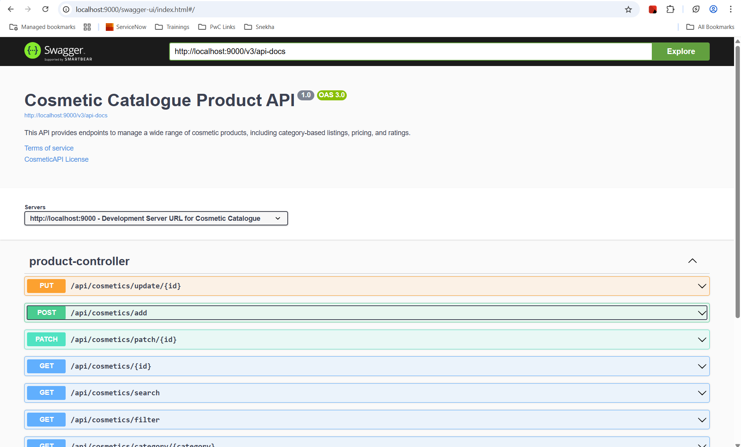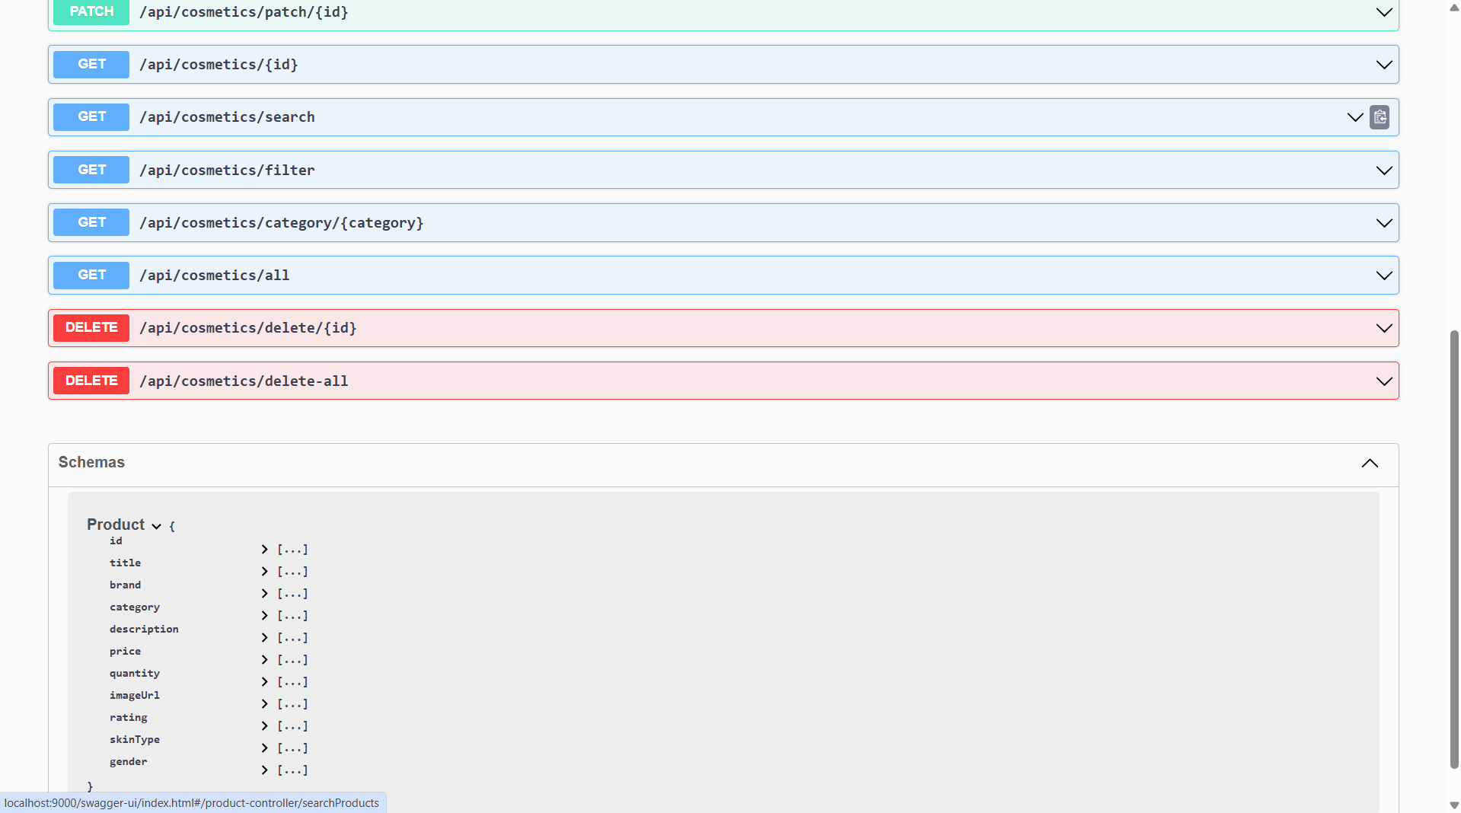

**Frontend Screenshots:**

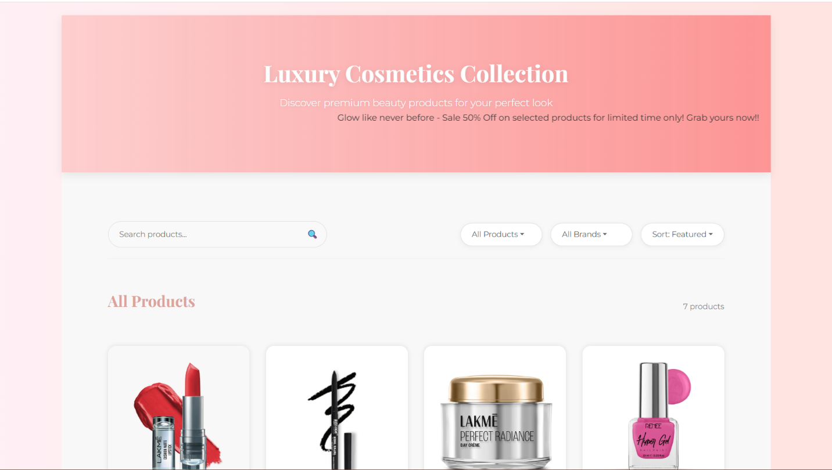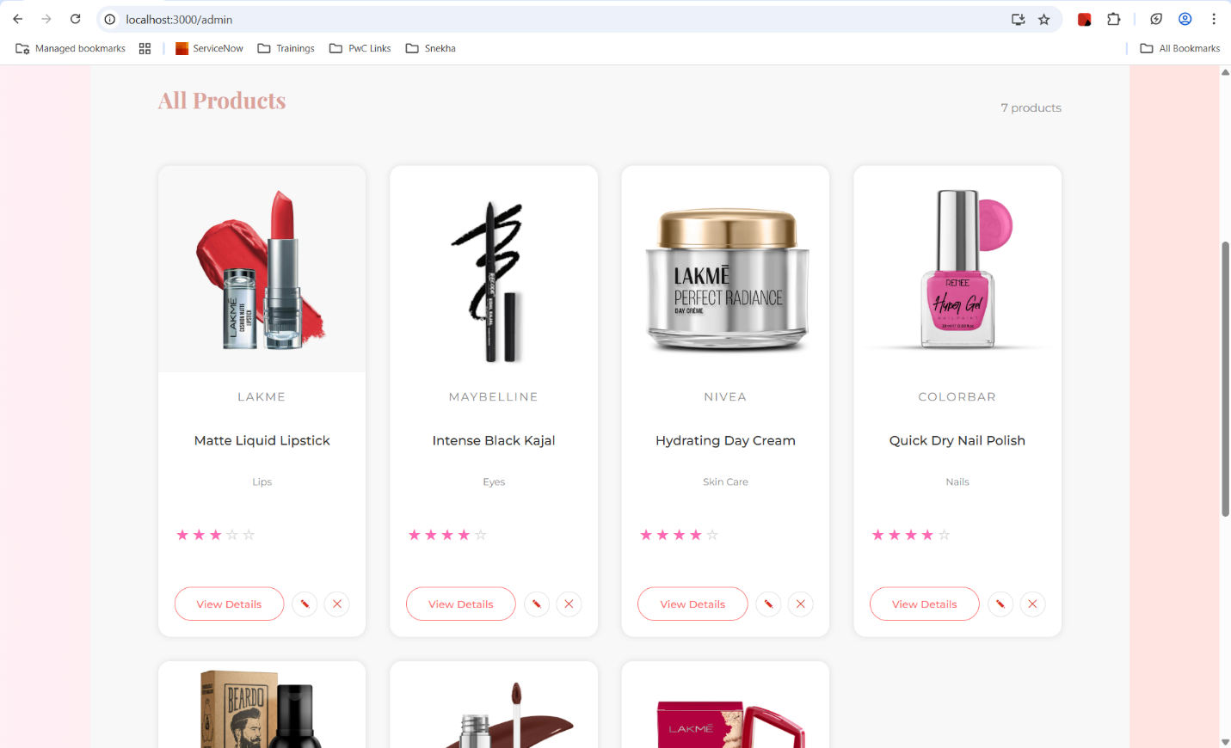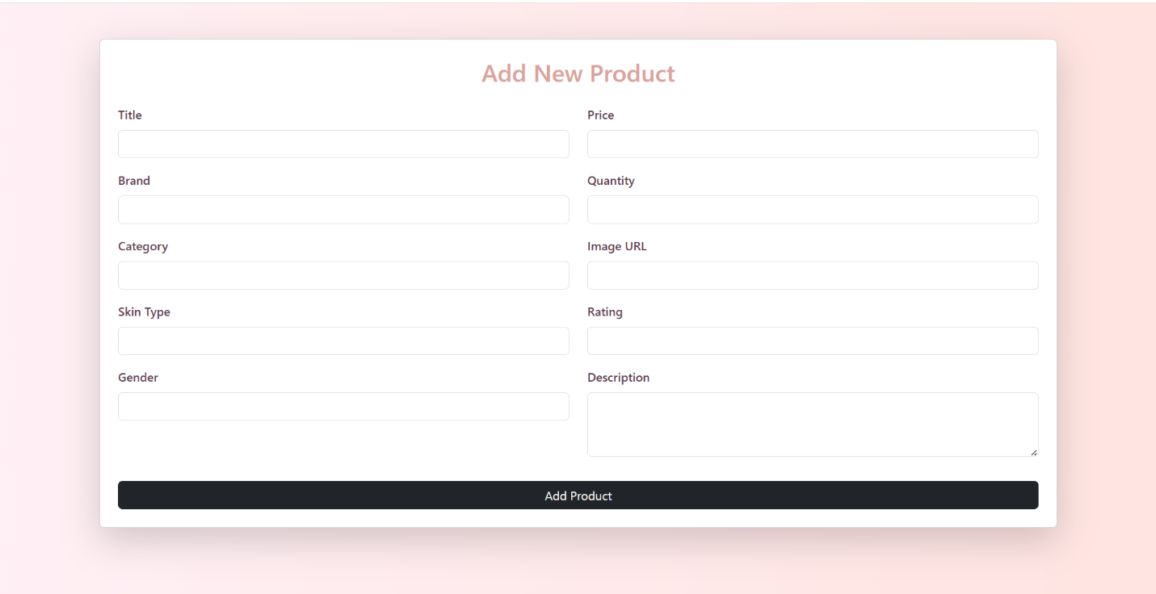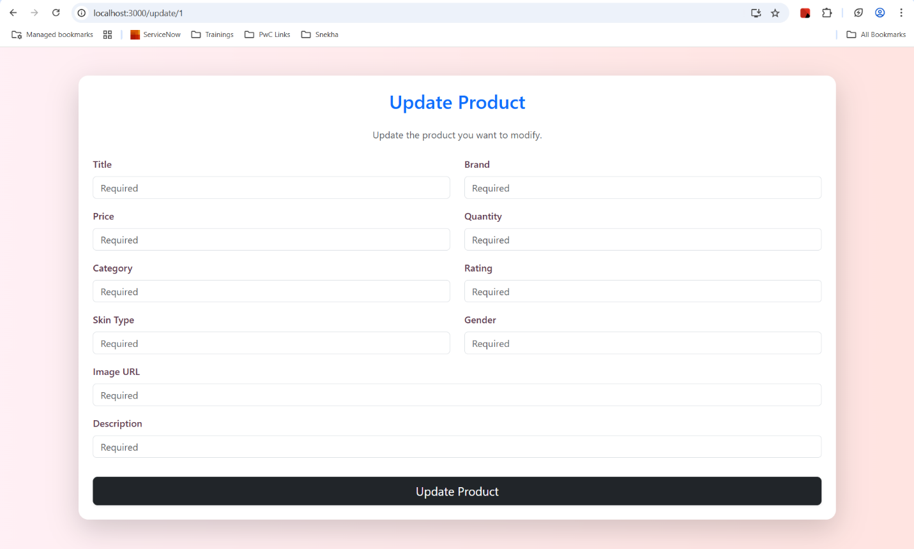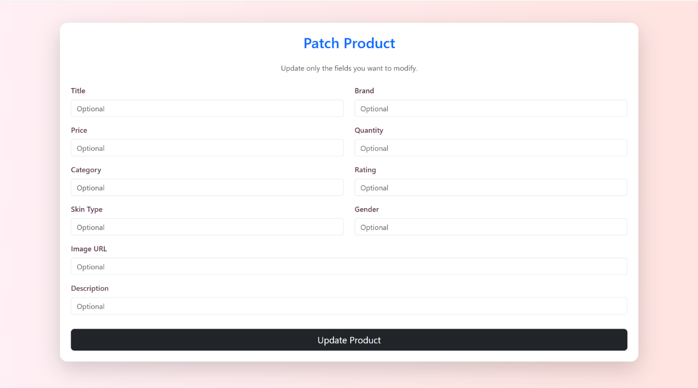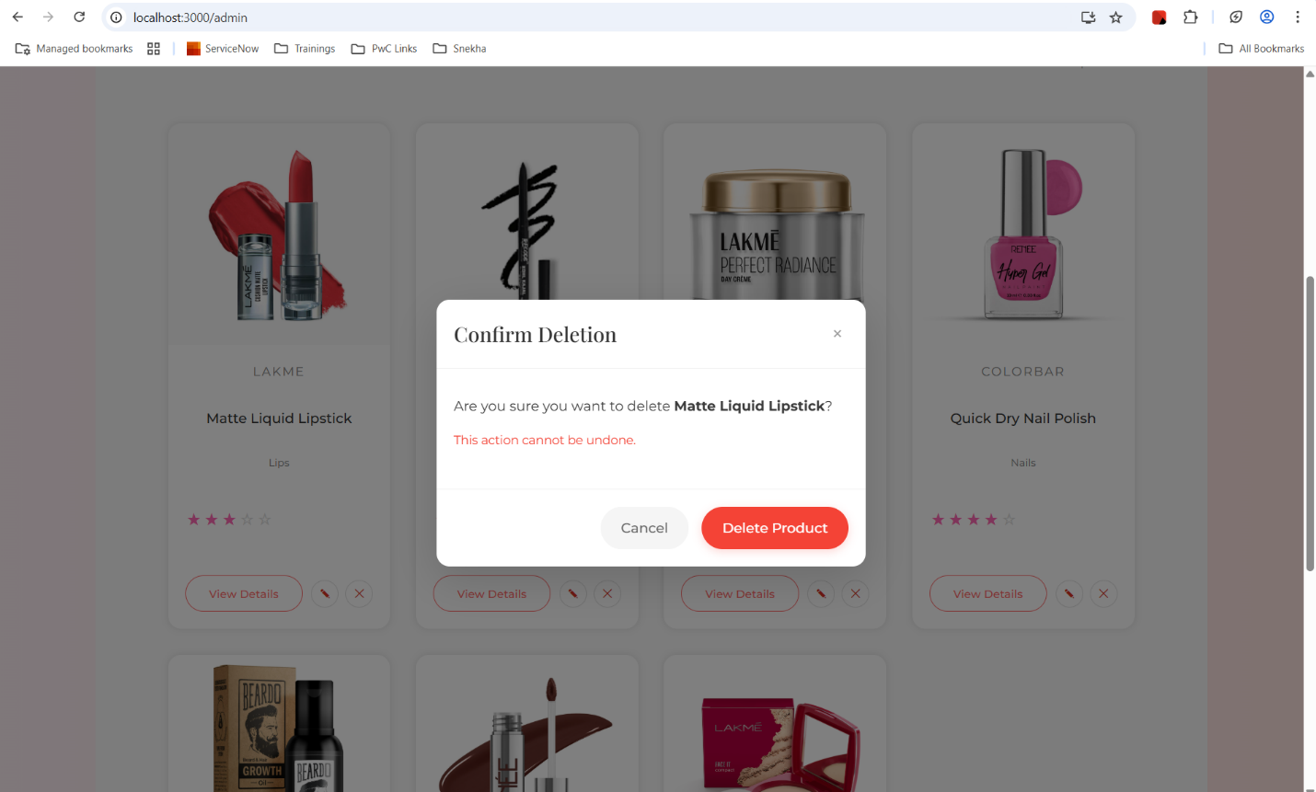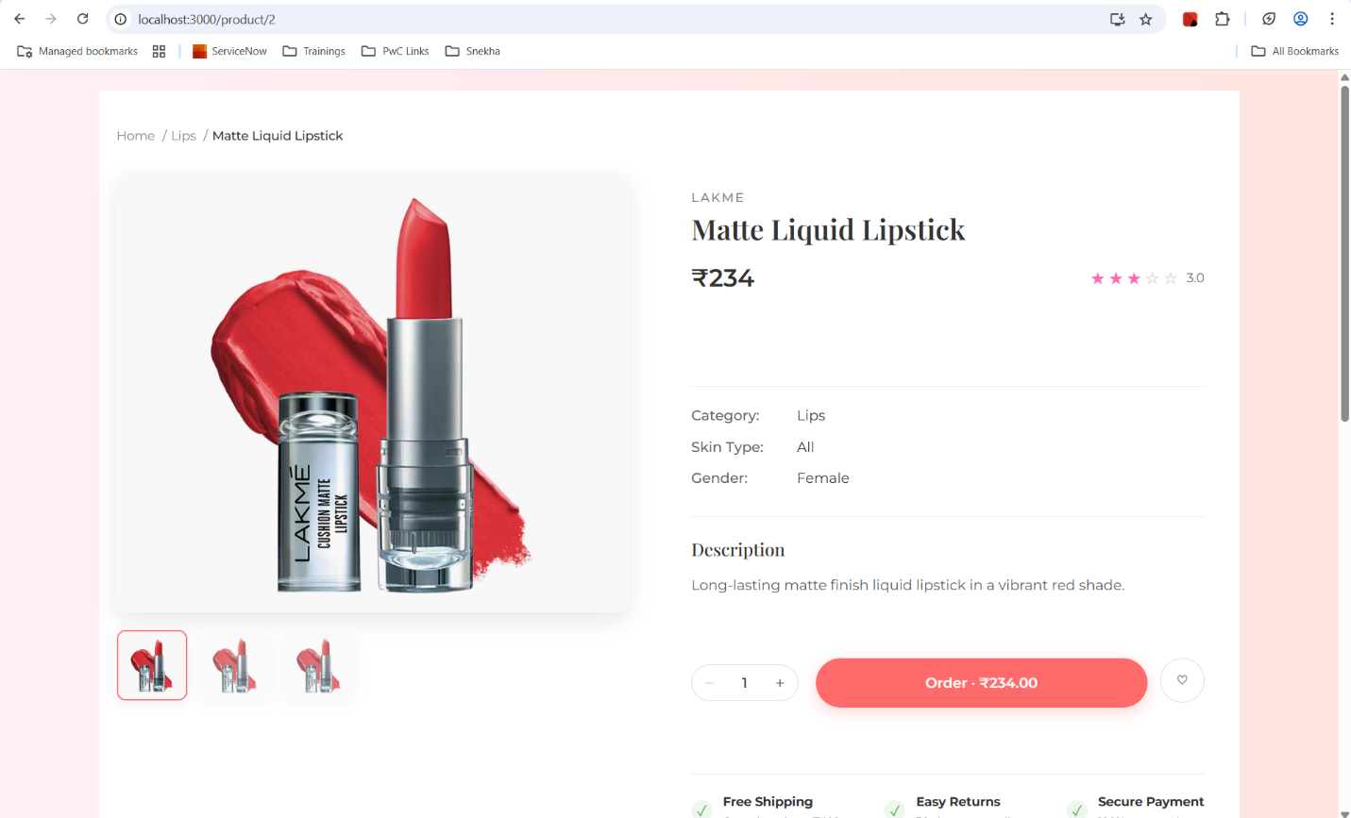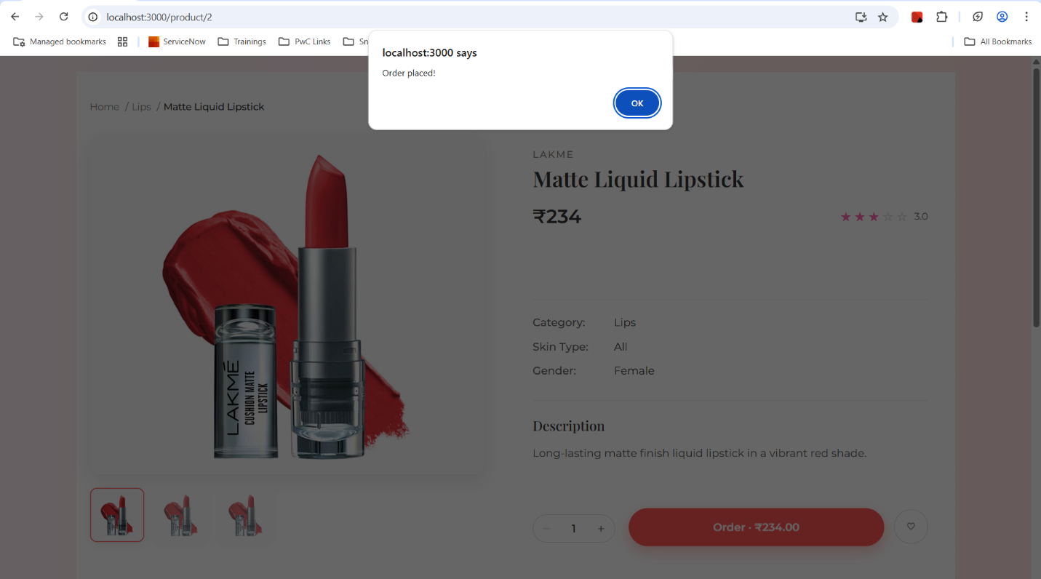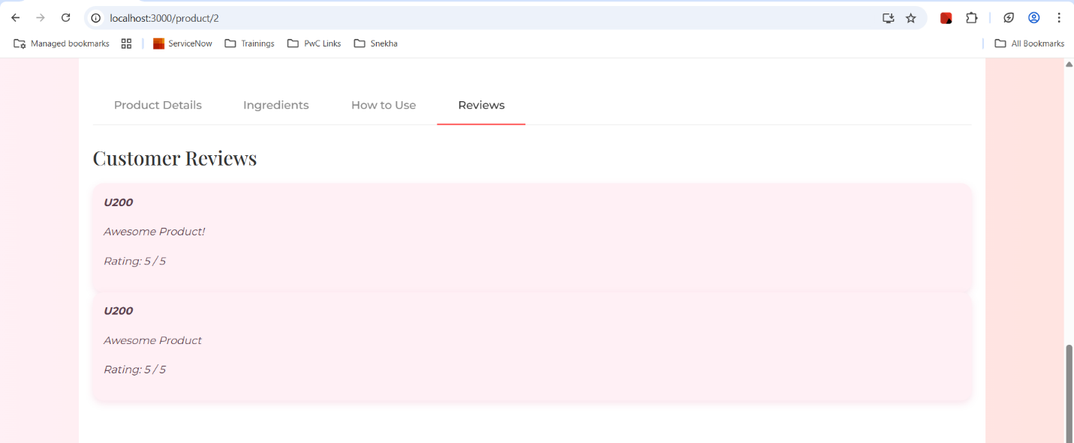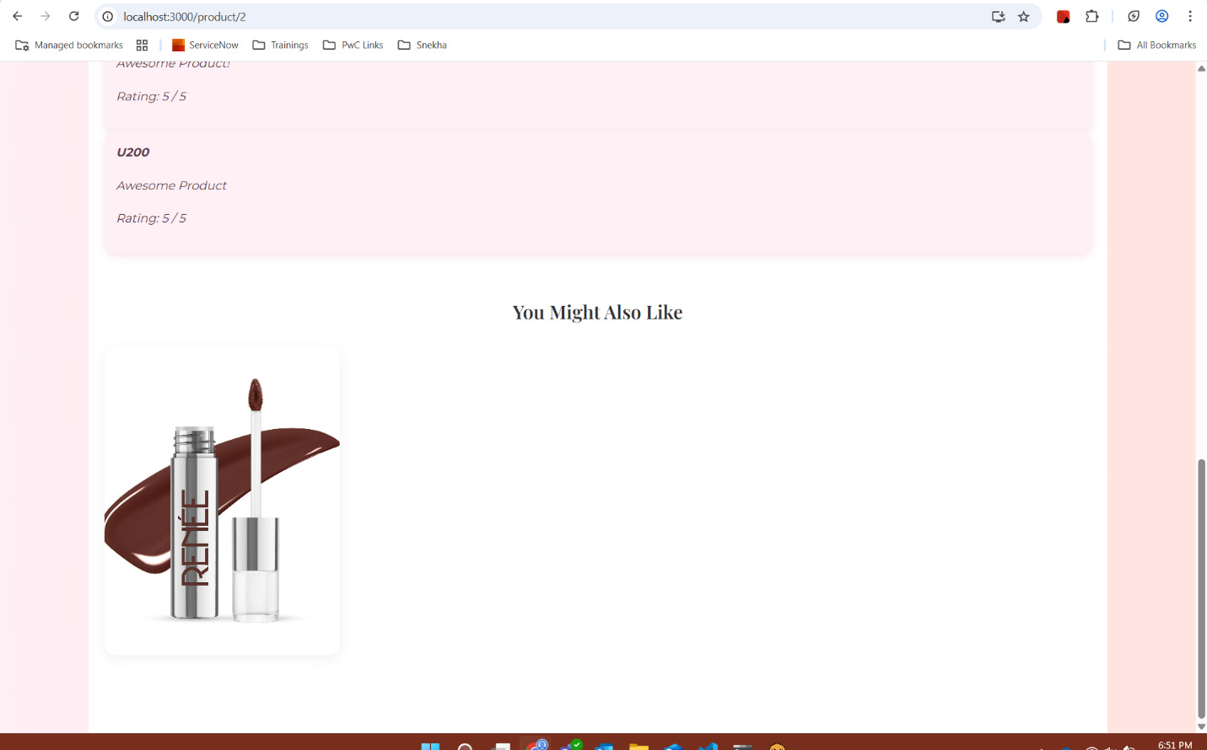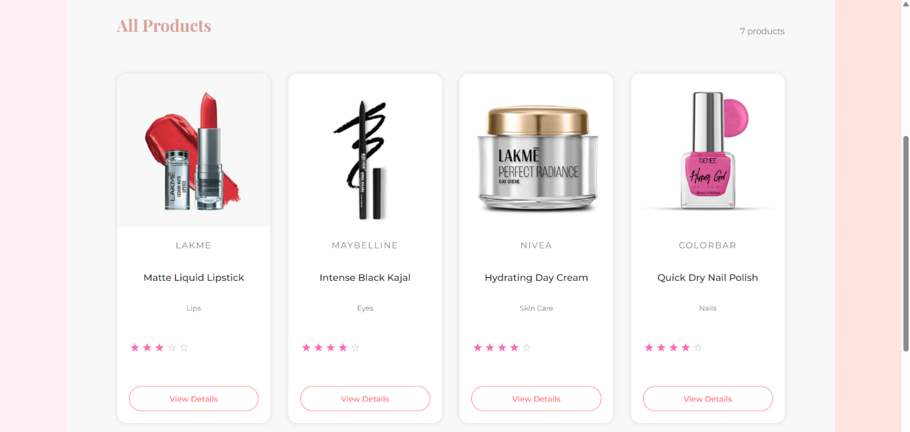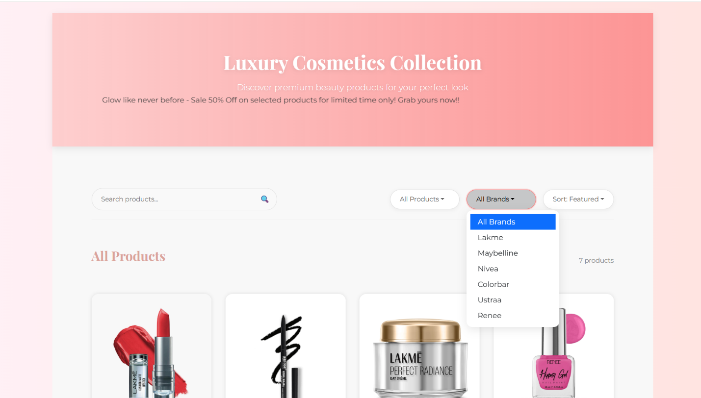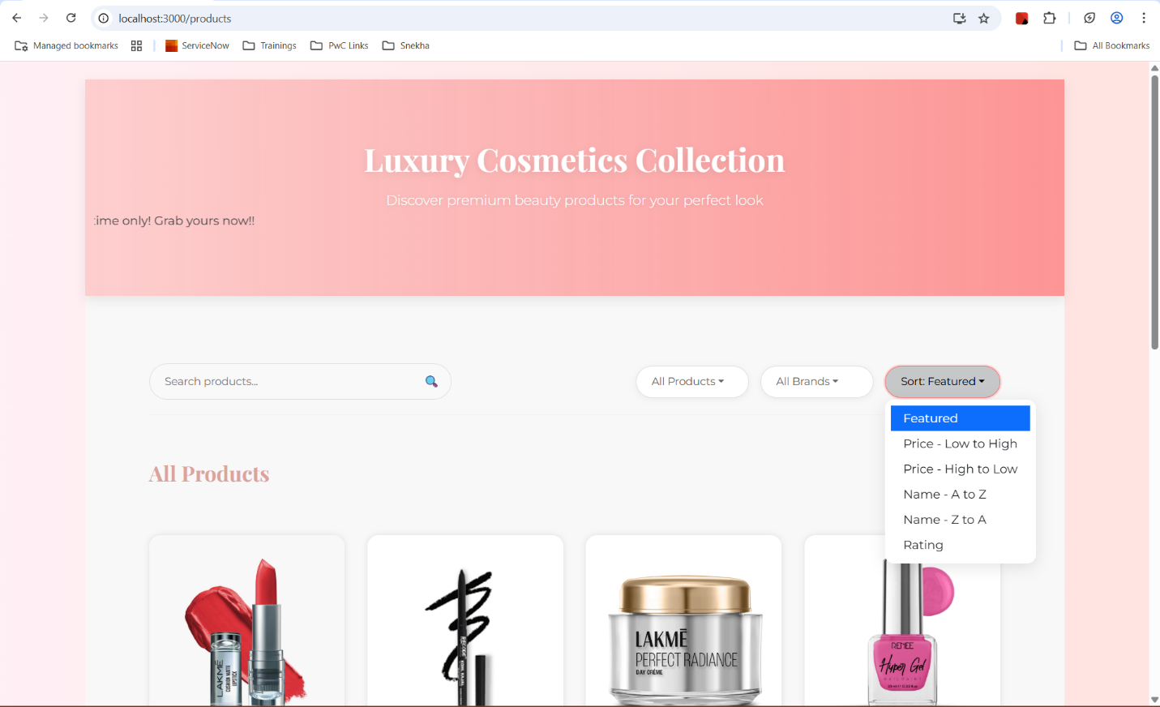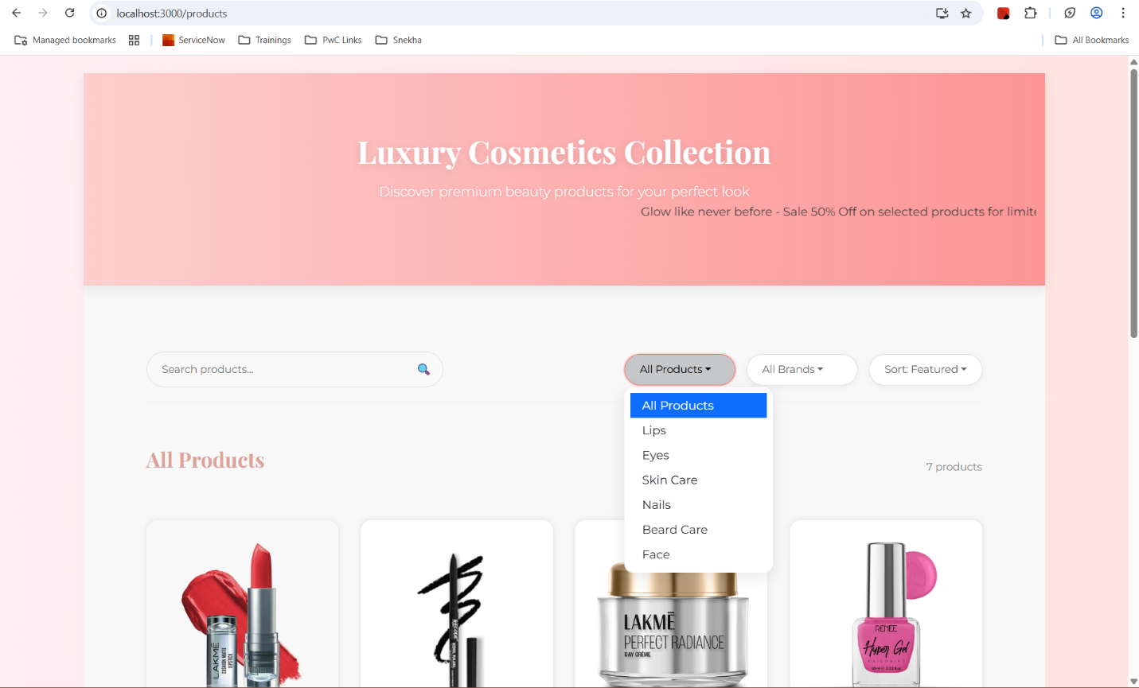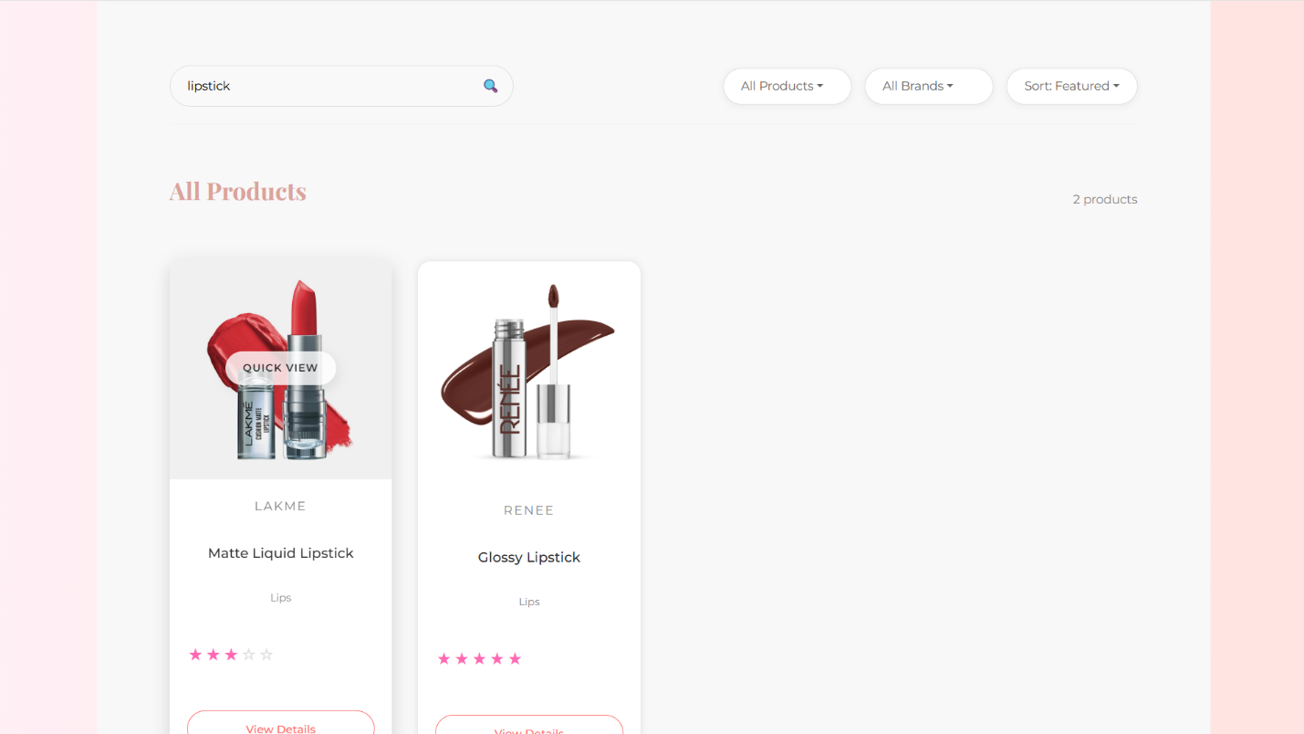

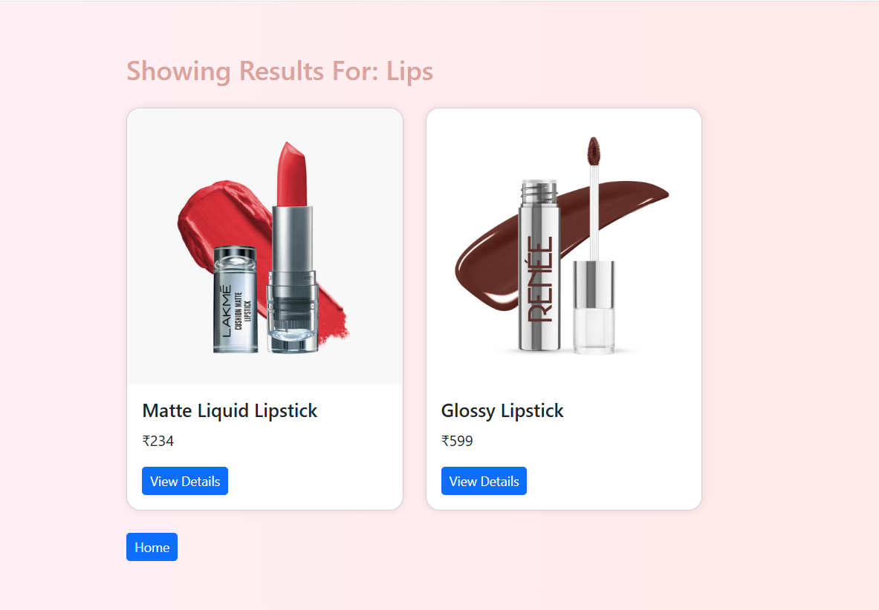

**Customer Service Documentation**

**Contributor:** Sushree Pallabi Nayak

The Customer Service component is a pivotal element of the project, designed to facilitate efficient user account management and enhance user engagement across the platform. Leveraging a modern technology stack, including MongoDB, Node.js, React, and Swagger, this component provides robust functionalities such as user registration, profile management, and customer history, integrated seamlessly between the frontend and backend.

**Role in Customer Service Development**

In the development of the Customer Service component, my primary focus was on creating a robust backend system that ensures seamless user account management and enhances the overall user experience on the platform. My contributions were pivotal in establishing the foundation for personalized and secure user interactions.

**Key Features:**

1. **User Registration and Login:**
   * Developed REST APIs using Node.js to facilitate secure account creation and login processes.
   * Implemented authentication mechanisms to verify user credentials, ensuring that only Contributorized users can access their accounts.
   * Utilized encryption techniques to securely store passwords, enhancing the security of user data.
2. **Profile Management:**
   * Provided APIs for users to retrieve and update their profile information. This includes personal details like name, email, skin type preferences, etc.
   * Enabled users to customize their profiles, allowing the recommendation system to deliver more personalized product suggestions.
3. **Mocked Order History:**
   * Created a feature that simulates order history for users, giving them a mock view of past interactions with the platform.
   * This helps in testing user engagement scenarios and enhances the realism of the user experience, even in early stages or testing environments.

**API Endpoints**

1. **Get All Customer Orders**
   * **Endpoint:** GET /orders/:id
   * **Description:** Retrieves all orders associated with a specific customer identified by their ID.
   * **Function:** getOrders
2. **Create a New Customer**
   * **Endpoint:** POST /add
   * **Description:** Allows the creation of a new customer profile in the system.
   * **Function:** createCustomer
3. **Get Customer Details**
   * **Endpoint:** GET /
   * **Description:** Fetches the details of all customers, providing a comprehensive view of user profiles.
   * **Function:** getCustomersDetails
4. **Get Specific Customer**
   * **Endpoint:** GET /:id
   * **Description:** Retrieves detailed information of a specific customer identified by their ID.
   * **Function:** getCustomers
5. **Update Customer Information**
   * **Endpoint:** PUT /:id
   * **Description:** Updates the profile information of a specific customer, allowing for personalization and data accuracy.
   * **Function:** updateCustomer
6. **Delete a Customer**
   * **Endpoint:** DELETE /:id
   * **Description:** Deletes a specific customer from the database, ensuring data management and integrity.
   * **Function:** deleteCustomer
7. **Add Order to a Customer**
   * **Endpoint:** POST /:id/orders
   * **Description:** Adds a new order to a specific customer's order history, enhancing engagement and tracking interactions.
   * **Function:** addOrderToCustomer

API Call Samples

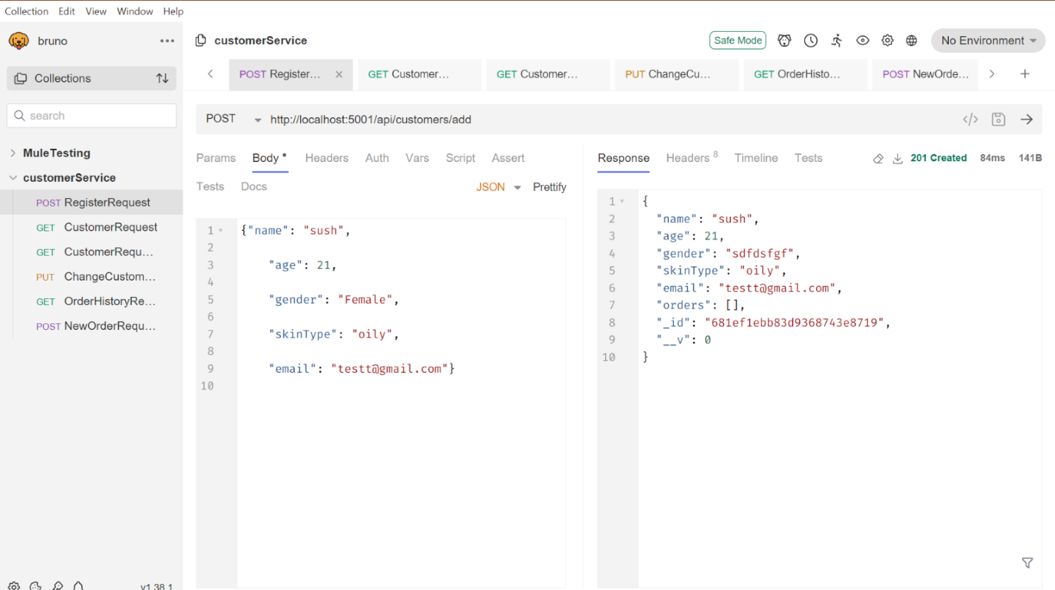

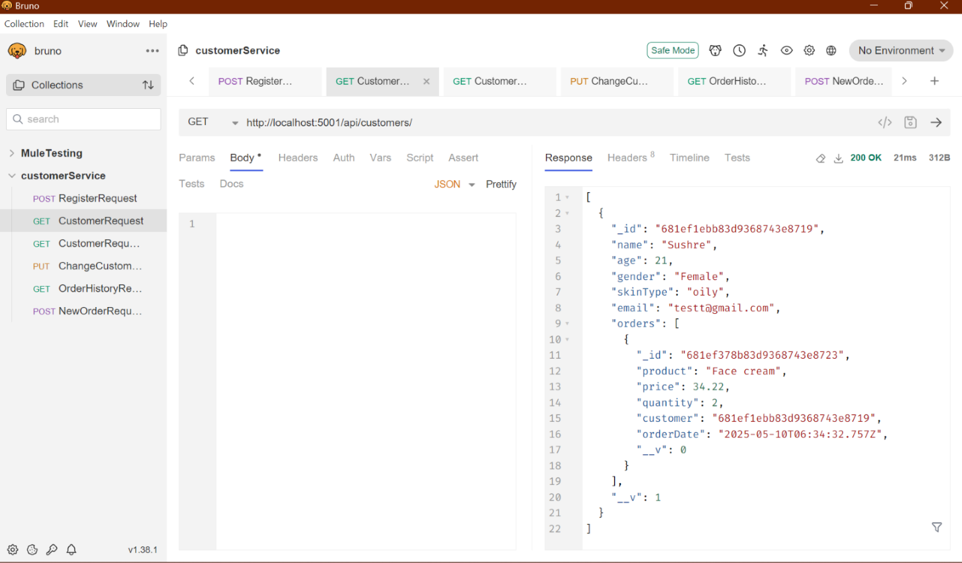

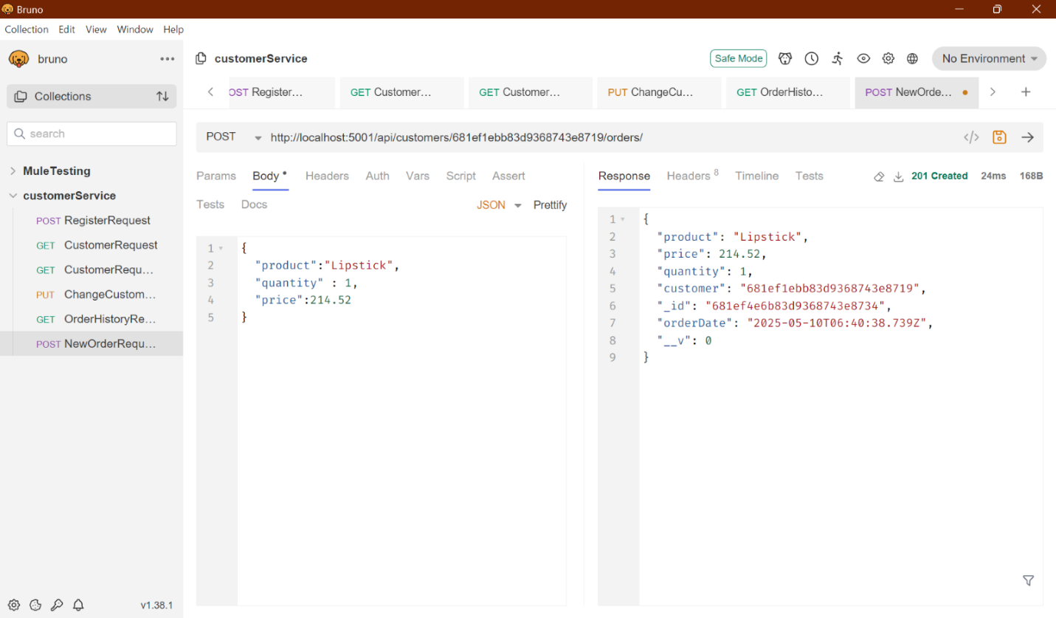

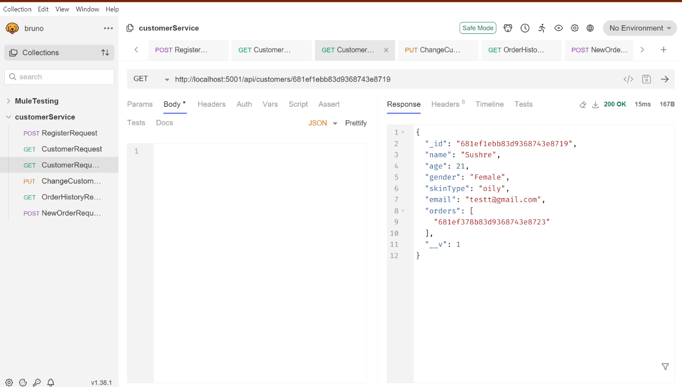[Text Wrapping Break]

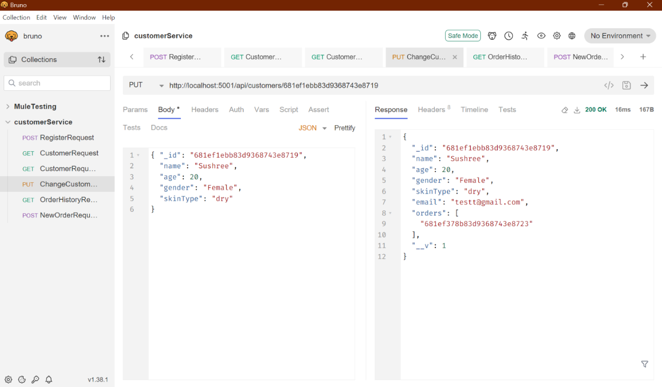

**Technical Implementation**

* **Express.js:** Utilized as the web application framework for building the APIs, offering a robust and flexible structure for handling HTTP requests.
* **Modular Code Structure:** Each API functionality is encapsulated in a separate function within the customerController.js file, promoting code reusability and maintainability.
* **Routing:** The APIs are organized using an Express router, ensuring clean and efficient routing of requests.

**Key Functionalities and Implementation**

**1. User Registration**

* **Objective:** Provide a seamless and secure mechanism for users to register and authenticate on the platform.

**Backend Implementation:**

* Developed RESTful APIs using Node.js to handle user registration and login processes.
* Change: The email serves as a customer's unique identifier in the system, ensuring uniqueness and easy retrieval of user profiles**.**

**Frontend Integration:**

* Created responsive registration and login forms using React, ensuring a user-friendly interface.
* Utilized Axios for HTTP requests to interact with backend APIs, efficiently managing user input and server responses.

This revision emphasizes the use of the email as the customer's unique identifier, integrating it seamlessly into the existing description.

Frontend:-

Follow these steps to create your account:

1. **Name:** Enter your full name.
2. **Age:** Provide your age.
3. **Gender:** Select your gender (optional).
4. **Skin Type:** Choose from Oily, Dry, Combination, Normal, Sensitive.
5. **Email:** Enter your email for login and updates.

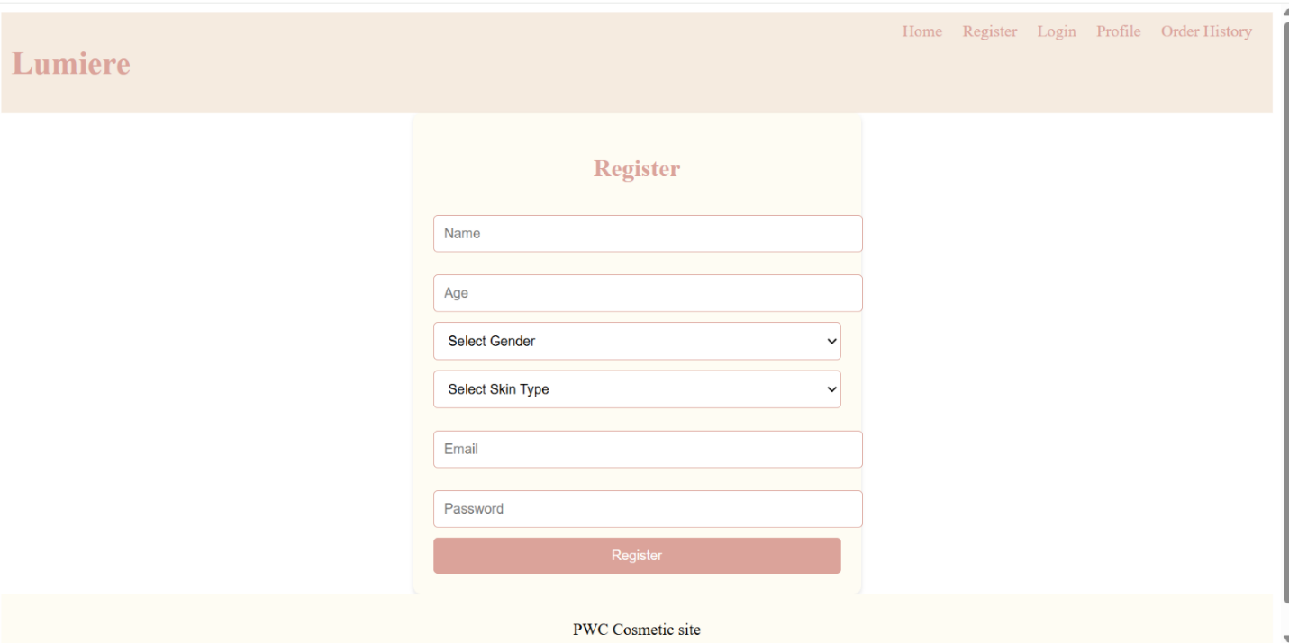

1. **Submit:** Click 'Register' and verify your email with the link sent to you.

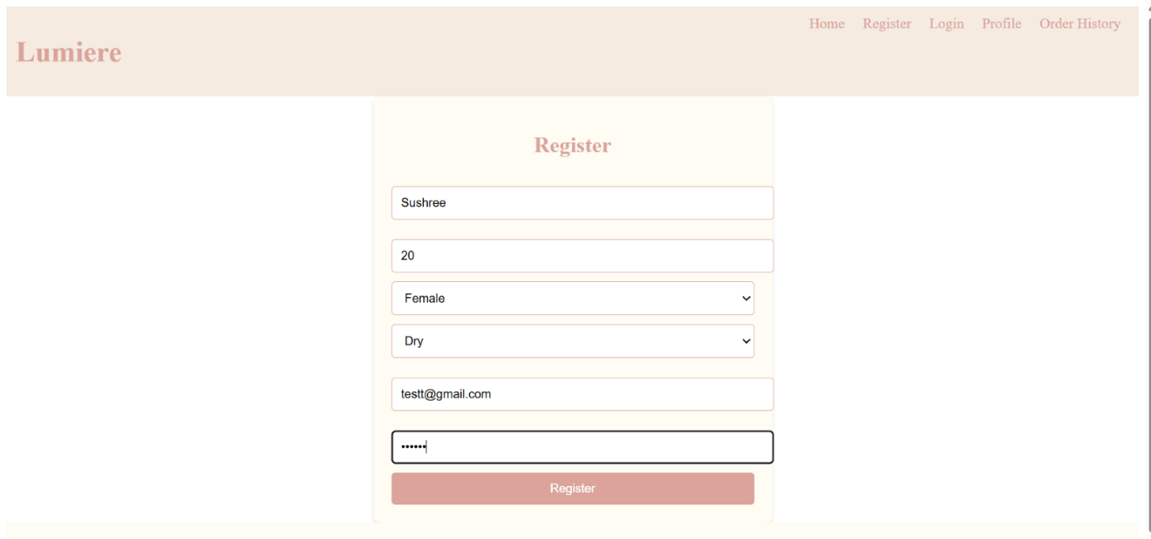

**2. Profile Management System**

* **Objective:** Enable users to manage their personal information and preferences effectively.
* **Backend Implementation:**
  + Developed APIs to allow users to retrieve and update their profiles stored in MongoDB.
  + Supported customizable fields such as username, email, and preferences, ensuring data flexibility and user personalization.
* **Frontend Integration:**
  + Designed an intuitive profile management dashboard using React, allowing users to view and edit their information comfortably.
  + Ensured real-time updates and feedback by integrating frontend components with backend APIs through Axios.

Frontend:-

Easily update your profile information below:

1. **ID:** View-only, cannot be changed.
2. **Email:** Update for login and notifications.

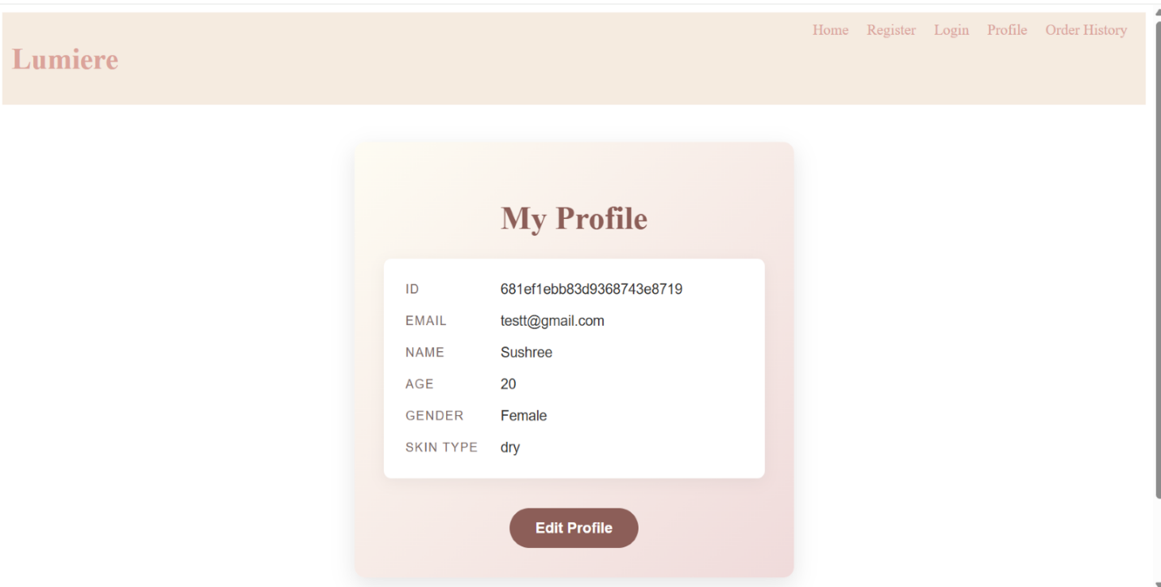

1. **Name**: Edit your full name.
2. **Age**: Adjust if needed for accurate recommendations.
3. **Gender**: Update if desired (optional).
4. **Skin Type**: Choose your current type: Oily, Dry, Combination, Normal, Sensitive.
5. **Save Changes**: Ensure accuracy, then click 'Save Changes.'

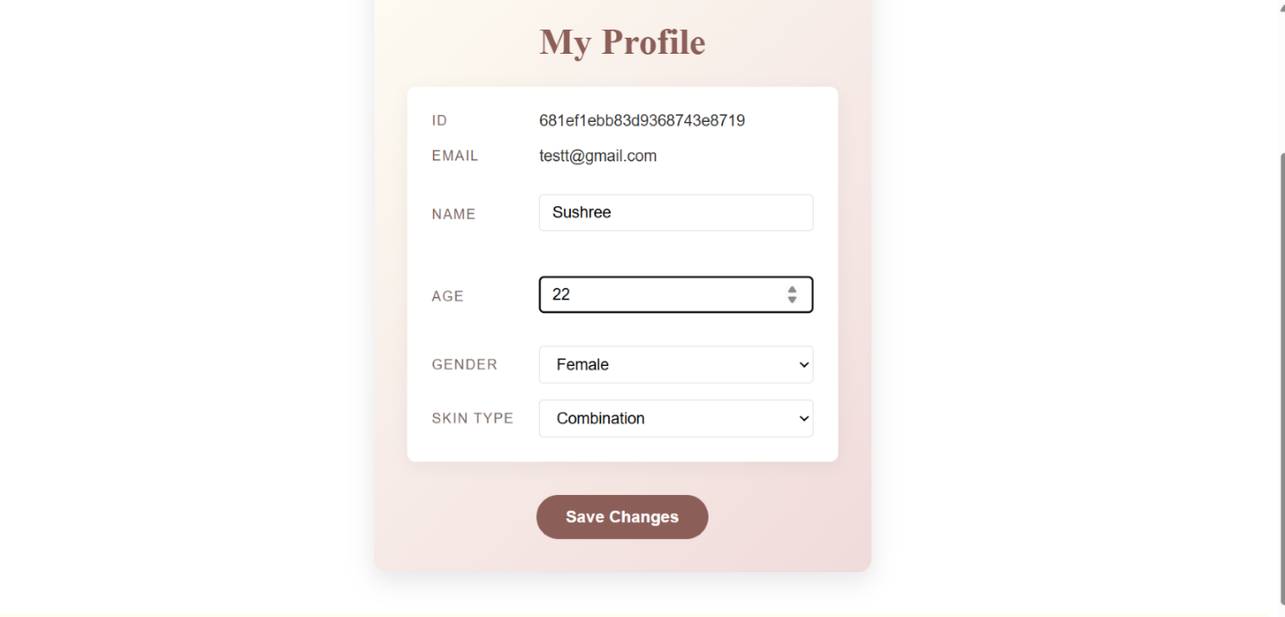

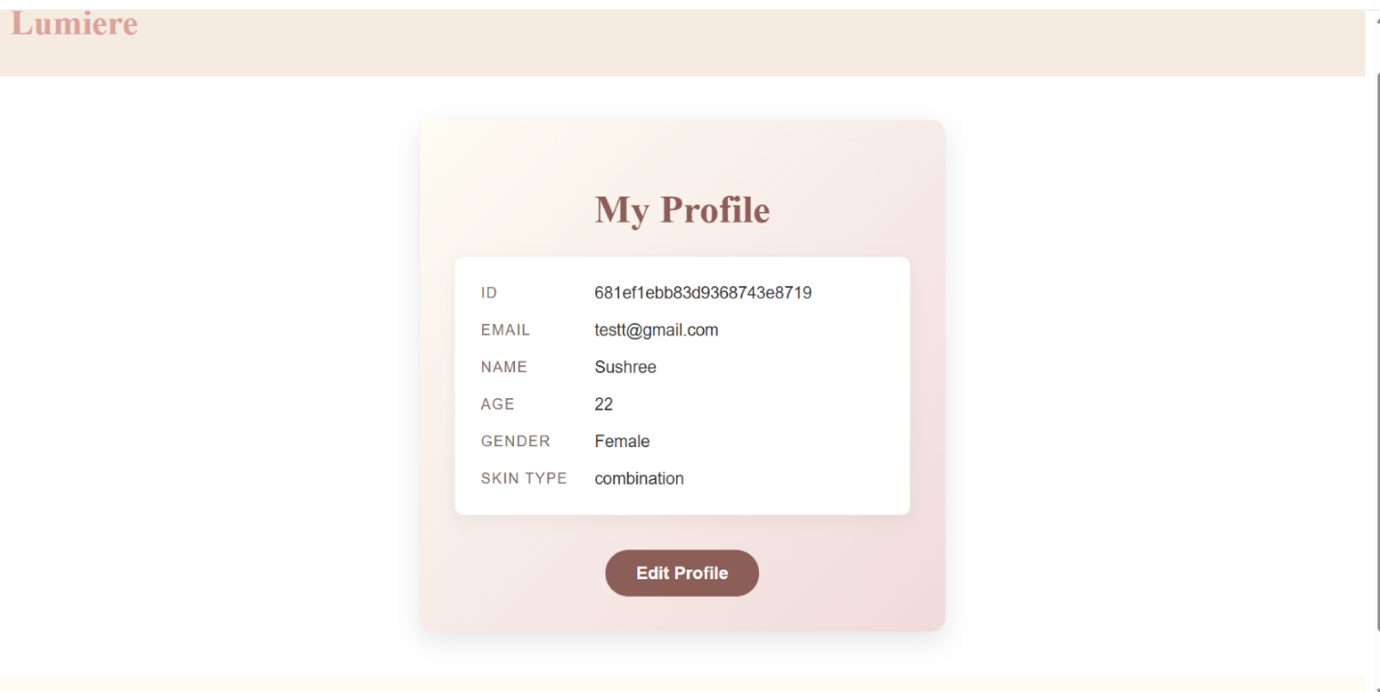

**3. Customer Order History**

* **Objective:** Simulate and manage a user's order history to enhance the user experience and engagement.
* **Backend Implementation:**
  + Designed a schema in MongoDB to store order history data, ensuring scalability and data integrity.
  + Developed APIs to fetch and display order history, providing users with a comprehensive view of their interactions.
* **Frontend Integration:**
  + Implemented a visually appealing order history section using React, offering users a detailed overview of past transactions.
  + Provided interactive elements to enhance user engagement, utilizing React's component-based architecture for efficient rendering.

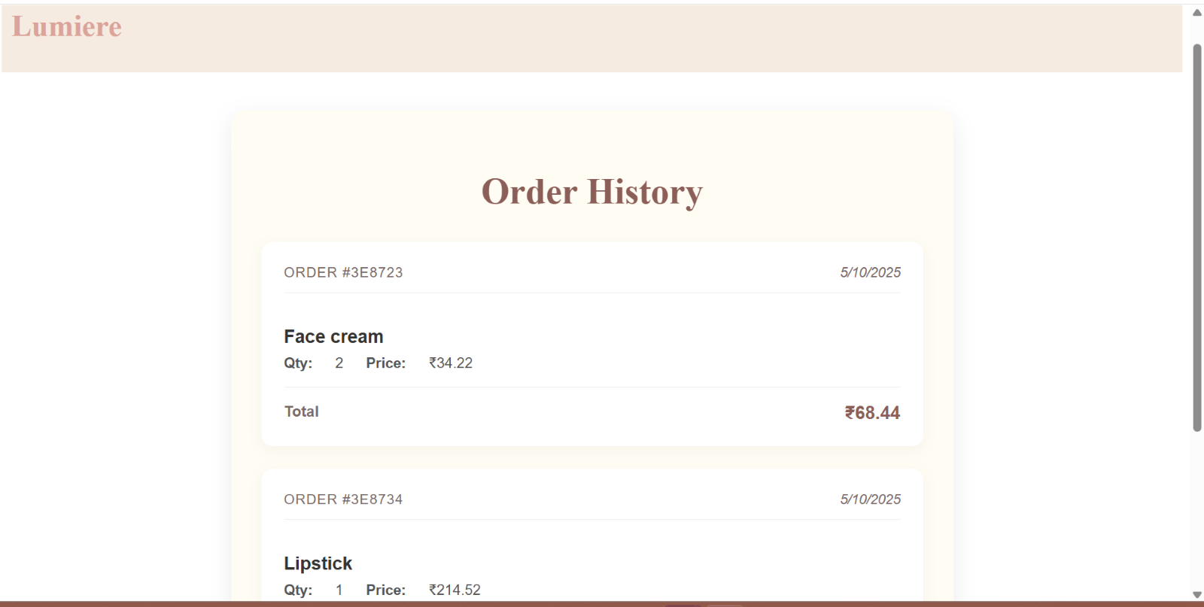

This summary provides a concise overview of the order, including key details like order number, date, product, quantity, price per unit, and the total cost.

**4.Integration and Documentation with Swagger**

* **API Documentation:** Utilized Swagger to document all API endpoints, providing a clear, interactive interface for developers to understand and test API functionalities.
* **Benefits of Swagger:**
  + Enhanced communication between frontend and backend teams, ensuring smooth integration and reducing development time.
  + Facilitated automated testing and debugging, improving the reliability and performance of API services.

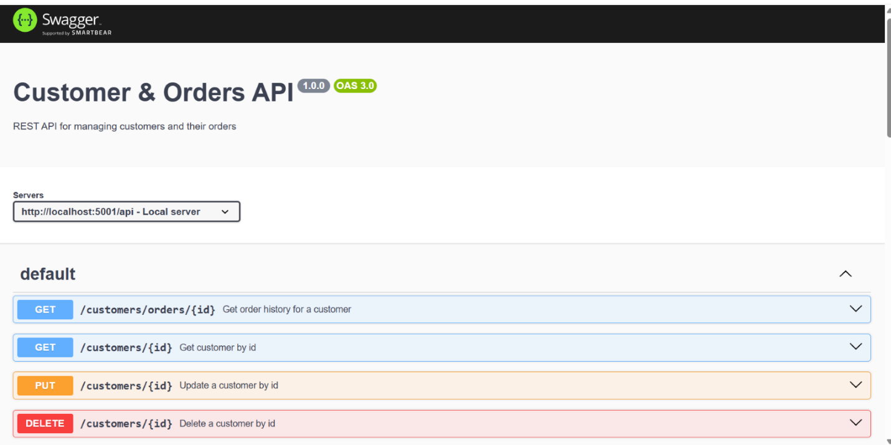

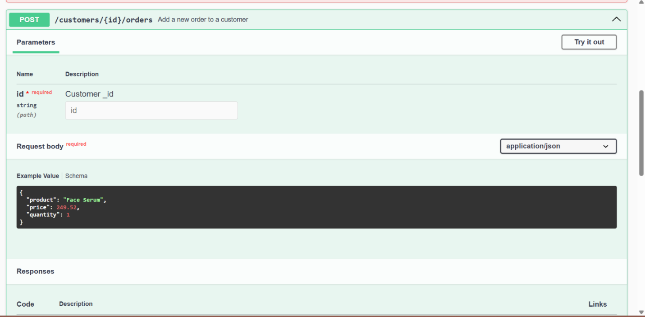

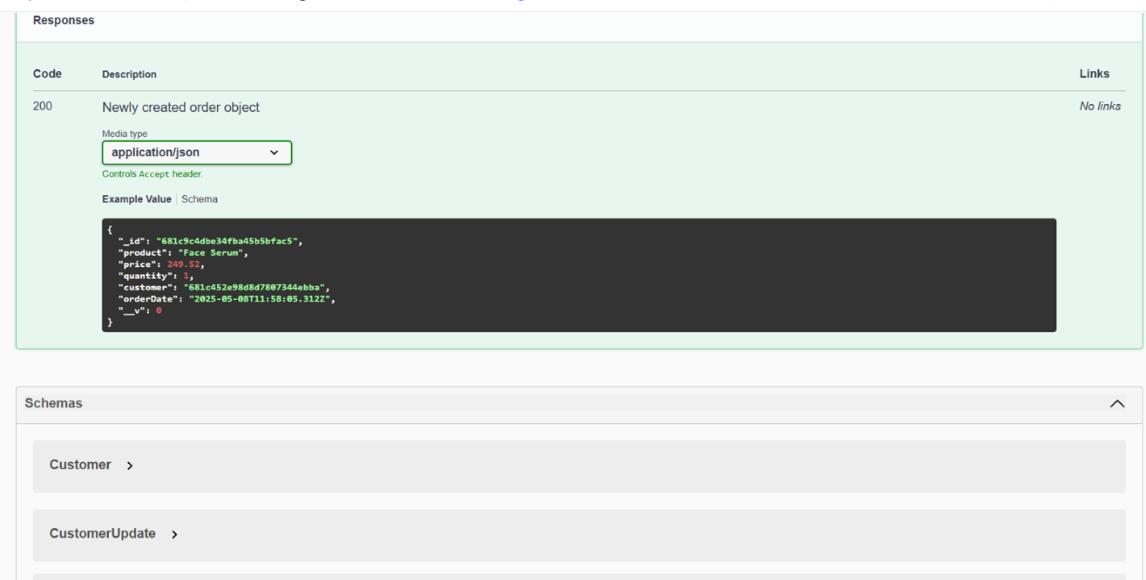

**Conclusion**

The Customer Service component built using MongoDB, Node.js, React, and Swagger, effectively addresses the platform's user management needs, providing a comprehensive, secure, and user-friendly solution. Through seamless integration and modern development practices, this component significantly enhances the overall platform experience, laying the foundation for future growth and innovation.

**Feedback Service Documentation**

**Contributor:** **Indukuri Divya Sai**

***Responsibilities:***

• **Feedback Service (Backend)**: Developed the Flask backend for collecting and storing customer feedback.  
• **Analytics**: Performed exploratory data analysis (EDA) on the collected feedback.  
• **Frontend Development**: Built a React-based UI to collect feedback via a form and display analytical insights.  
• **API Development**: Developed RESTful APIs.

***Introduction***

This project presents a cosmetics ecommerce website feedback collection and analytics platform built using a microservices-based architecture. The core idea is to allow customers to submit product reviews via a feedback form and then analyze that data to extract meaningful insights using exploratory data analysis and sentiment analysis. The backend is powered by Python Flask, while the frontend leverages React for dynamic user interfaces. And Swagger is implemented to document and test the APIs effectively. The system emphasizes scalability, user experience, and actionable feedback visualization.  
  
**Motivation:**  
The cosmetics industry thrives on customer opinions and feedback. Many consumers rely on reviews before trying a new product. However, scattered and unstructured reviews limit brands from gaining meaningful insights.  
  
**Importance of Real-Time Reviews:**  
With the rise of e-commerce, real-time reviews help both customers and businesses. Analyzing reviews can reveal patterns in satisfaction, complaints, or preferences based on demographics or skin types.

**Project Scope:**  
This project focuses on creating a feedback collection platform, analyzing textual reviews, and visualizing trends and sentiments in a user-friendly interface. The system aims to support product teams, marketers, and customers alike.

***Problem Statement***  
1. Cosmetic brands currently lack a structured mechanism to gather and evaluate customer feedback in real time.  
2. Customers want recommendations or evaluations based on personalized factors like skin type, sensitivity, or tone.  
3. A user-centric, analytics-driven feedback system can bridge this gap and promote smarter product decisions.

***Objectives:***  
• Design a responsive feedback form for users to submit reviews.  
• Perform Exploratory Data Analysis (EDA) using Text Blob and pandas.  
• Visualize analytical insights via graphs and charts.  
• Secure the backend with JWT authentication.  
• Document and test all APIs using Swagger UI.

***System Architecture***  
  
• **Frontend (React):** Collects user feedback and displays analysis results.  
• **Backend (Flask):** Handles API logic, JWT authentication, data storage, and analytics processing.  
• **Database (SQLite/MySQL):** Stores user reviews.  
• **Analytics Service:** Performs EDA (Exploratory Data Analysis)

***Database Schema (Feedback Table):***

|  |  |  |
| --- | --- | --- |
| **Column Name** | **Data Type** | **Description** |
| id | INTEGER | Primary Key, Auto Increment |
| Name/Uid | TEXT | Name of the customer submitting feedback |
| ProductName/Pid | TEXT | Name of the cosmetic product |
| Rating | INTEGER | Product Rating |
| Feedback Text | TEXT | The feedback/review provided |
| timestamp | DATETIME | Time stamp when the feedback was submitted |

***REST API Routes and Outputs***  
  
**1. POST /feedback/submit**  
• **Description**: Submit feedback for a cosmetic product.  
• **Parameters**:  
• name: User’s name (String)  
• ProductName: Product name (String)  
• feedback text: User’s feedback (String)  
• **Response**:  
• 200 OK: Successfully received feedback.  
• 400 Bad Request: Missing required fields or invalid data.

**2. POST /feedback/upload-csv**  
• **Description**: Upload a CSV file containing multiple feedback entries.  
• **Parameters**:  
• file: CSV file containing feedback data (File)  
• **Response**:  
• 200 OK: File uploaded and processed successfully.  
• 400 Bad Request: Invalid file format or missing file.  
  
**3. GET /feedback/analytics**  
• **Description**: Get insights from the collected feedback (e.g., sentiment analysis).  
• **Response**:  
• 200 OK: Returns sentiment analysis and EDA results in JSON format.

***Architecture***   
  
• **Frontend (React)**: User submits feedback, interacts with the dashboard.  
• **Backend (Flask)**: Handles API requests, processes feedback, performs sentiment analysis.  
• **Database**: Stores feedback and metadata.  
• **Analytics**: Performs EDA and visualizes insights.  
• **Authentication**: JWT secures access to endpoints.

***Project Glossary***

• **Feedback**: User’s comments or reviews about a cosmetic product.

• **EDA (Exploratory Data Analysis)**: Analyzing datasets to summarize their main characteristics.

• **JWT**: JSON Web Tokens used for secure user authentication.

• **Swagger UI**: Interactive API documentation that allows users to test the APIs.

***OUTPUTS:***

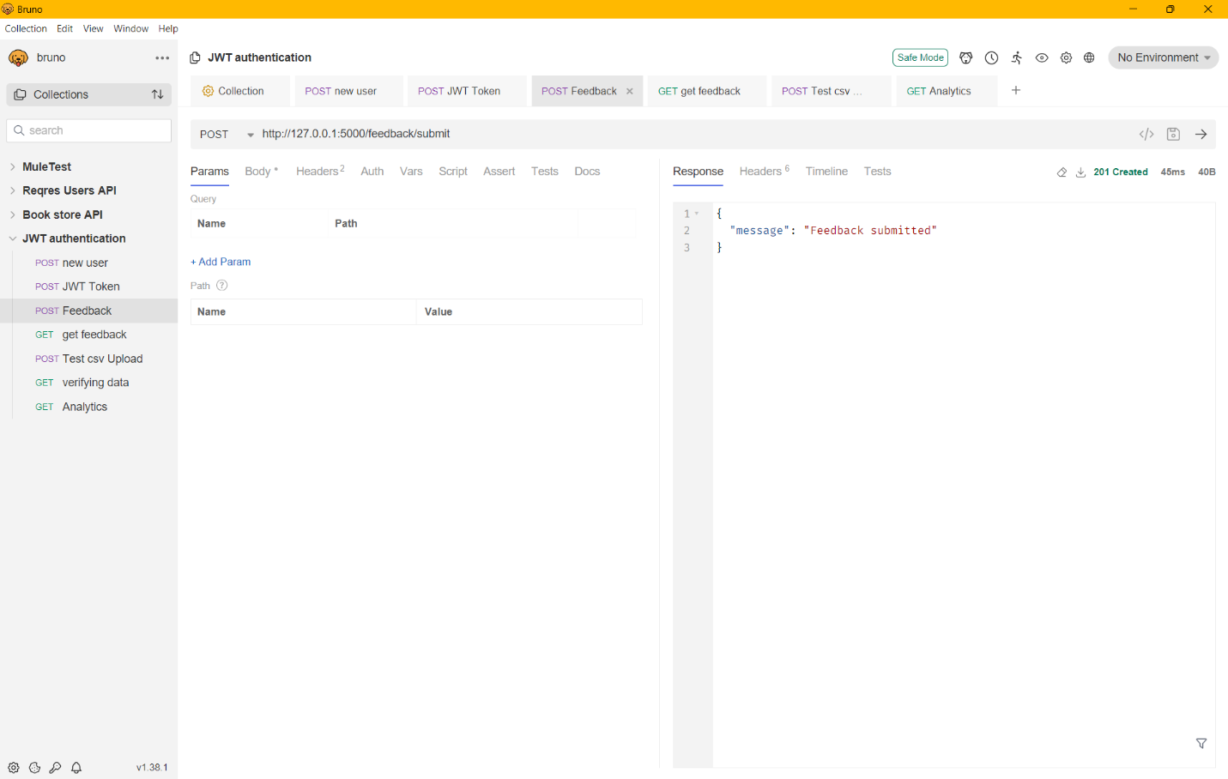

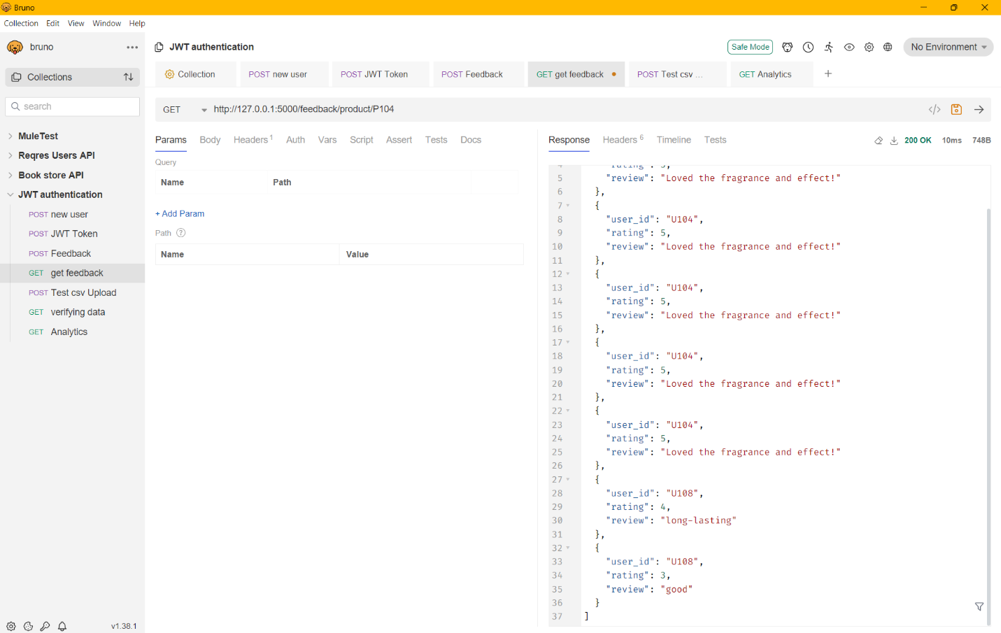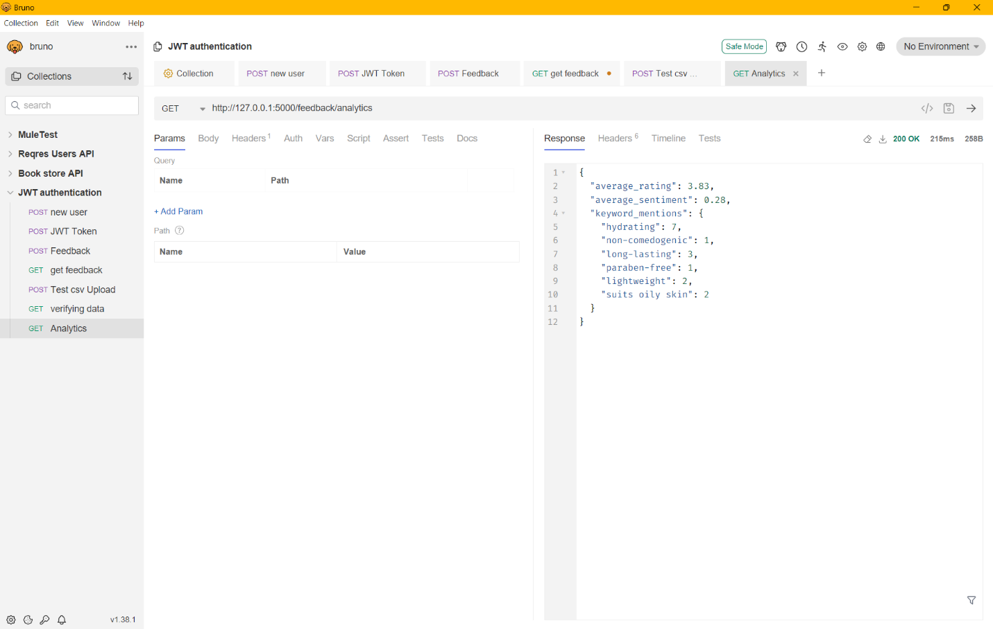

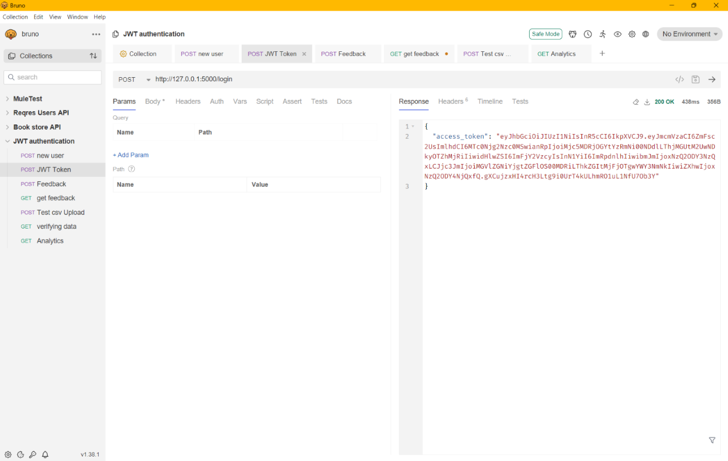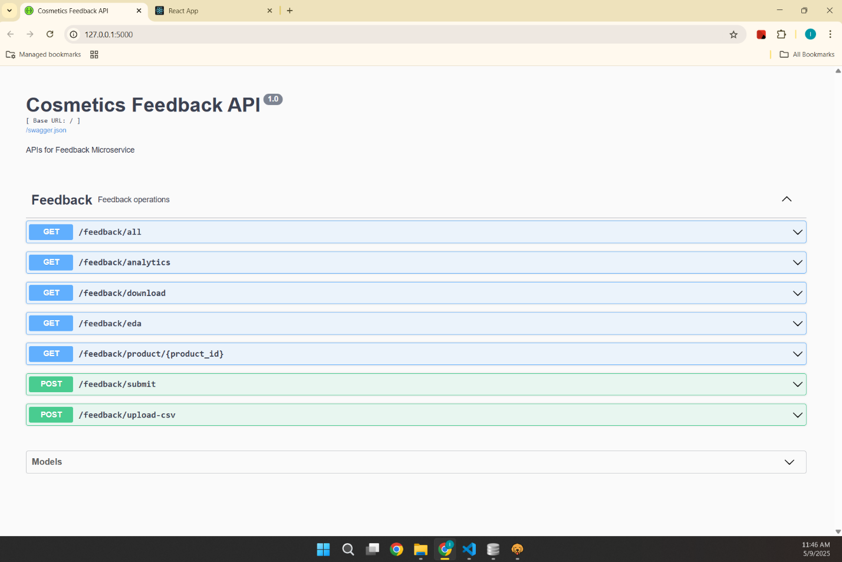

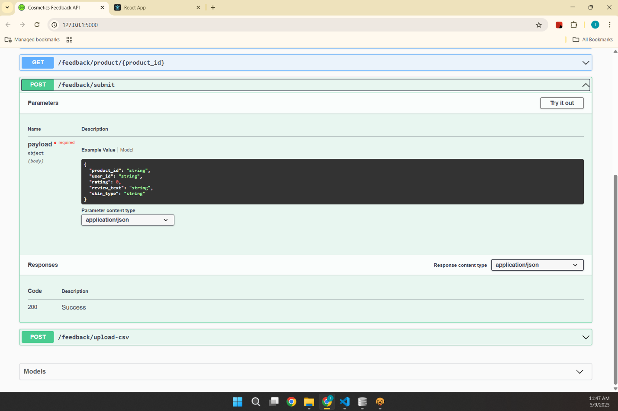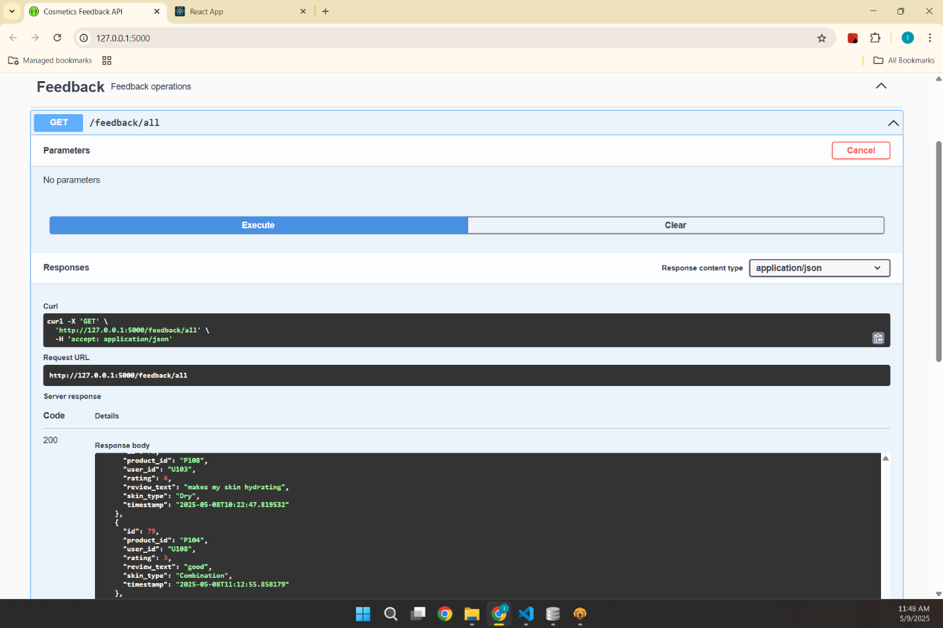

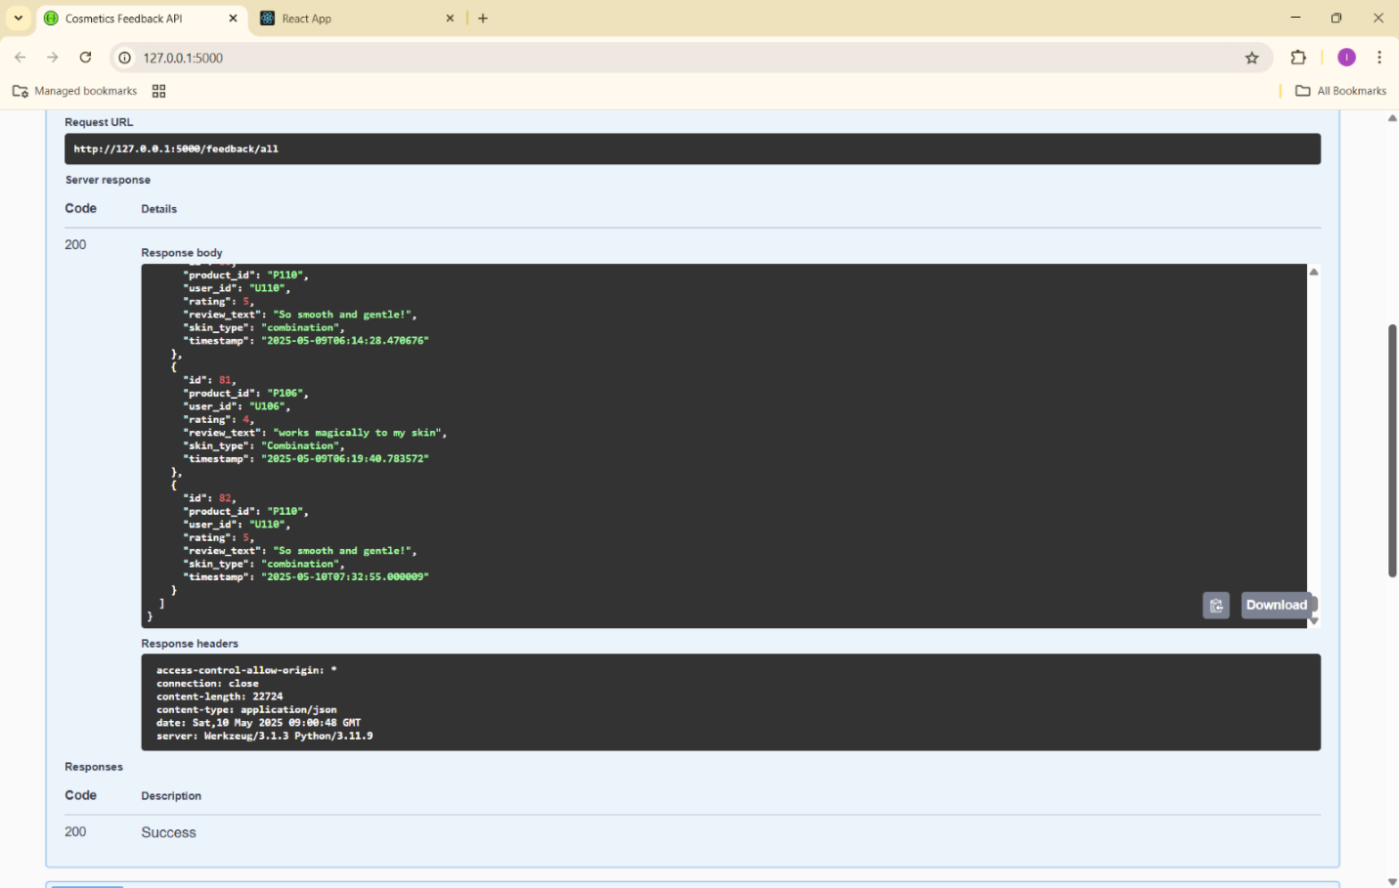

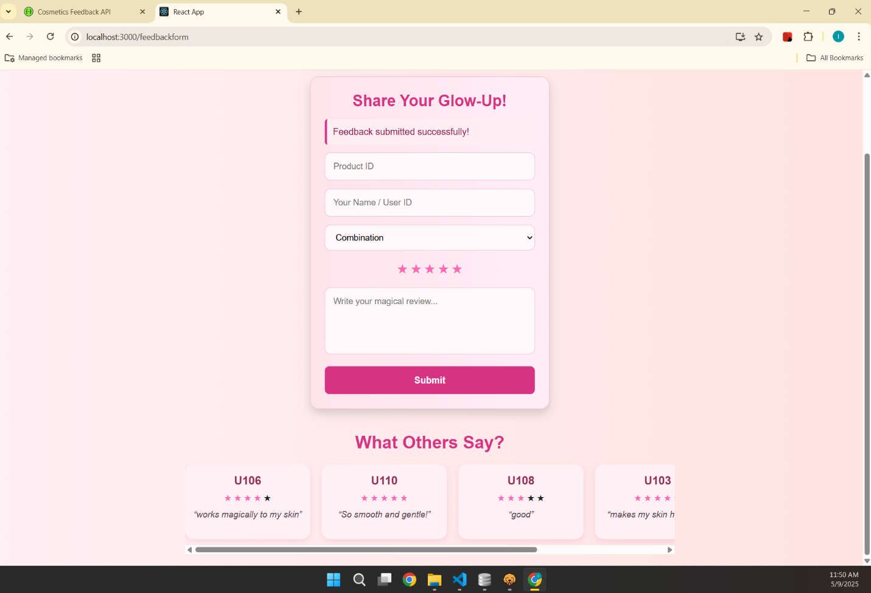

**Recommendations Service Documentation**

**Contributor:** Joanisa Hasan

**Key Contribution**

My specific contributions to this project focus on product recommendation platform that provides users with personalized product suggestions, allows them to submit and analyze reviews, and offers promotional content through a dynamic user interface.

As a key contributor to this project, my responsibilities included:

* **Recommendation Service:** Developed a system to recommend skincare products based on skin type. The service fetches and lists the top 5 rated products for each skin type and provides personalized skincare tips.
* **Review Submission and Sentiment Analysis:** Implemented a review submission functionality that stores user reviews. Integrated sentiment analysis to determine if a product review is positive or negative, displaying an emoji reaction to enhance user interaction.
* **Frontend Design:** Designed the frontend interface, focusing on UI/UX friendliness. Incorporated brand-specific elements such as the name and color palette. Implemented error handling to improve user experience.
* **User and Admin Login:** Developed the customer login, admin login, and customer sign-up pages. Ensured a seamless user authentication process with a focus on security and usability.

**Implementation**

Here is the breakdown of the backend and frontend components, including the implementation details of various services such as recommendation, review submission, promotional pop-ups, and sentiment analysis.

1. **Recommendation Service**

**Backend:**

**Route:** /api/recommendations/skin_type (GET)

**Description:** Fetch product recommendations based on a given skin type (e.g., oily, dry, sensitive).

**Request Parameters:** skin_type (Query parameter)

**Example Request:**

GET <http://localhost:9000/api/recommendations/skin_type?skin_type=oily>

Backend Logic (in app.py):

* Accepts skin_type as a query parameter and returns a list of recommended products.
* Fetches data from the products table in the database and filters it based on the skin type.

**Response Example:**

[

{

"product_id": "P002",

"product_name": "Oil-Free Gel Moisturizer"

},

{

"product_id": "P005",

"product_name": "Mattifying Toner"

}

]

**Frontend:**

**Component**: Recommendations.js

**Description:** Displays a list of recommended products based on the user's selected skin type.

**Frontend Logic:**

* The user selects a skin type from a dropdown.
* A request is sent to the backend to retrieve product recommendations.
* The product list is displayed dynamically.

2. **Submit Review Service**

**Backend:**

**Route:** /api/reviews (POST)

**Description:** Submit a product review with a rating.

**Request Body:**

{ "product_id": "P001",

"review": "This is a really great product!",

"rating": 5}

**Backend Logic (in app.py):**

* The backend accepts a POST request to submit a review for a product.
* The review and rating are stored in the reviews table in the database.
* Sentiment analysis can be triggered upon submission.

**Response Example:**

{

"message": "Review submitted successfully"

}

**Frontend:**

**Component:** ReviewForm.js

**Description:** Allows users to submit reviews for products.

**Frontend Logic:**

* Users input a review and rating for a product.
* The review is sent to the backend upon form submission.

3. **Promo PopUp Service**

**Backend:**

**Route:** /api/promo (GET)

**Description:** Fetch promotional content for popup display.

**Backend Logic (in app.py):**

* This endpoint returns promotional content like discounts or seasonal offers.
* Data can be static or dynamic, depending on your business needs.

**Response Example:**

{

"title": "Spring Sale - 20% Off",

"message": "Hurry up! Get 20% off on all products this Spring season."

}

**Frontend:**

**Component:** PromoPopup.js

**Description:** Displays a promotional popup when the user visits the site.

**Frontend Logic:**

* Fetches promotional content from the backend.
* If a promotion is available, it shows a popup to the user.

4. **Sentiment Analysis Service**

**Backend:**

**Route:** /api/sentiment (POST)

**Description:** Analyze the sentiment of a product review (positive or negative).

**Request Body:**

{

"review": "I absolutely love this product!"

}

**Backend Logic (in analysis.py):**

* Uses TextBlob or similar libraries to analyze the sentiment of the review.
* Classifies reviews as positive, neutral, or negative.
* The result is returned to the frontend.

**Response Example:**

{

"sentiment": "positive"

}

**Frontend:**

**Component:** SentimentDisplay.js

**Description:** Displays the sentiment of the review.

**Frontend Logic:**

* After the user submits a review, the sentiment is displayed.
* The component fetches sentiment analysis results from the backend.

**REST API Routes**

**1. Recommendation Service**

**Backend Route:** **/api/recommendations/skin_type (GET)**

* **Description:** Fetches product recommendations based on a specified skin type.
* **Request Parameters:** skin_type (Query parameter)
* **Response Example:**

**JSON:**

[

{

"product_id": "P002",

"product_name": "Oil-Free Gel Moisturizer"

},

{

"product_id": "P005",

"product_name": "Mattifying Toner"

}

]

**2. Submit Review Service**

**Backend Route:** **/api/reviews (POST)**

* **Description:** Allows users to submit a product review, including a rating.
* **Request Body:**

**JSON:**

{

"product_id": "P001",

"review": "This is a really great product!",

"rating": 5

}

* **Response Example:**

**JSON:**

{

"message": "Review submitted successfully"

}

**3. Sentiment Analysis Service**

**Backend Route:** **/api/sentiment (POST)**

* **Description:** Analyzes the sentiment of a submitted product review.
* **Request Body:**

**JSON:**

{

"review": "I absolutely love this product!"

}

* **Response Example:**

**JSON:**

{

"sentiment": "positive"

}

**Database Schema**

The following describes the core tables utilized in the Lumière platform:

**products Table**

* **product_id** (Primary Key): Unique identifier for each product.
* **product_name**: Name of the product.
* **skin_type**: The skin type the product is suited for.
* **average_rating**: Average user rating for the product.

**reviews Table**

* **review_id** (Primary Key): Unique identifier for each review.
* **product_id** (Foreign Key): Identifier linking the review to a product.
* **review_text**: Text of the user review.
* **rating**: Numeric rating provided by the user.
* **sentiment**: Sentiment analysis result (e.g., positive, neutral, negative).

**users Table**

* **user_id** (Primary Key): Unique identifier for each user.
* **username**: User's login name.
* **password_hash**: Encrypted password for secure authentication.
* **role**: User role, such as 'customer' or 'admin'.

**OUTPUT**

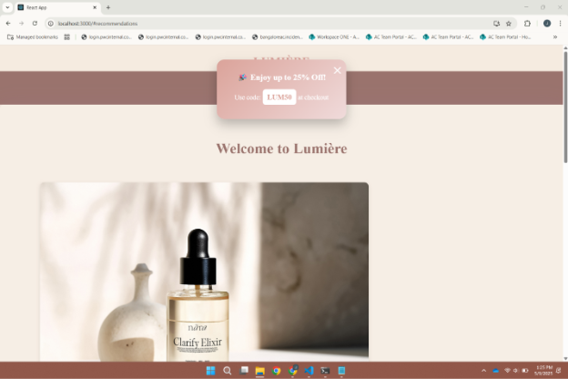**Page Layout**

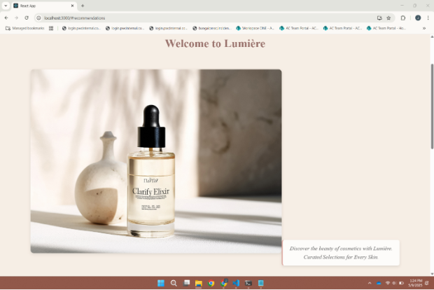

**Recommendations:**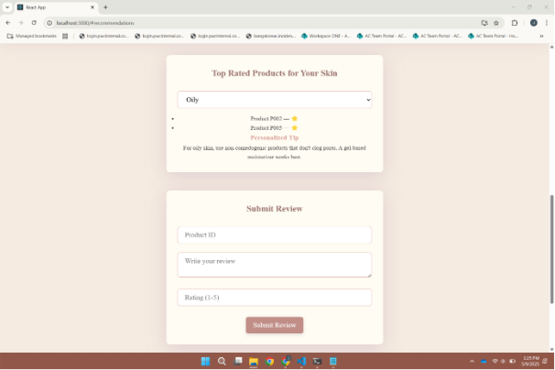

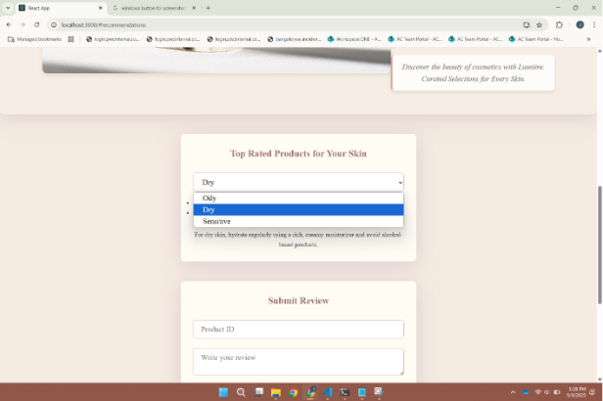

**Submit Review:** 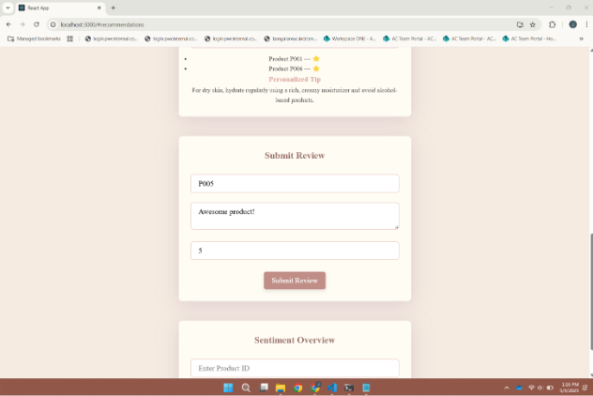

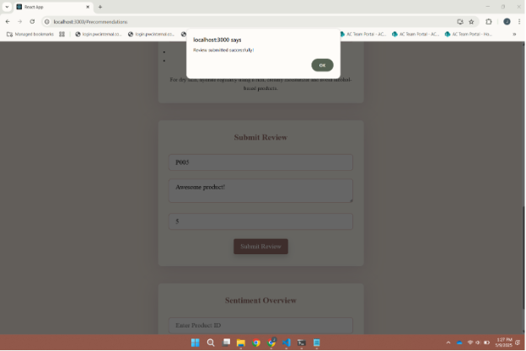

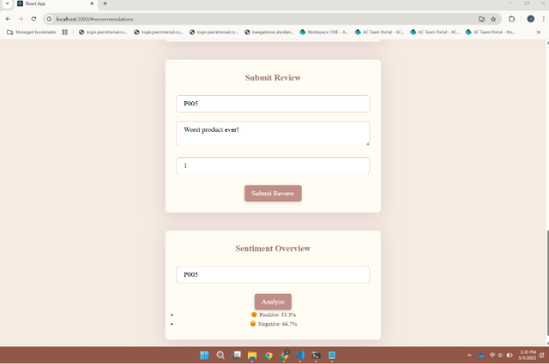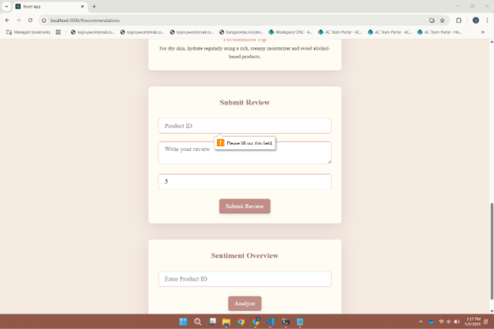

**Sentiment Analysis:**

**REST API Routes (Bruno):**

**Recommendations:**  
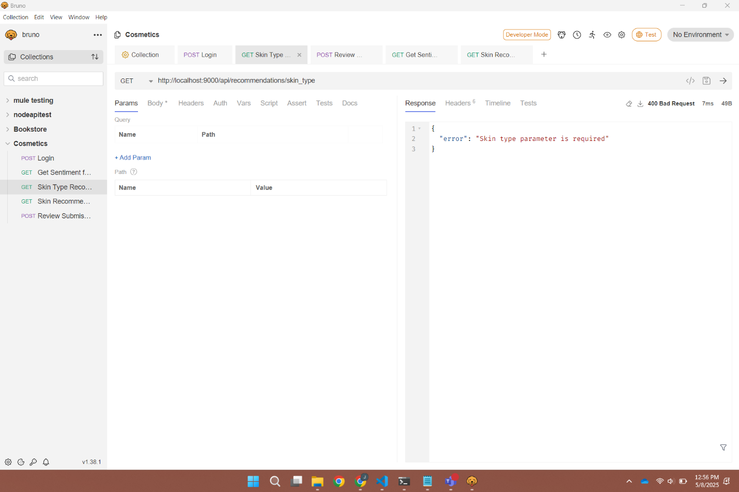

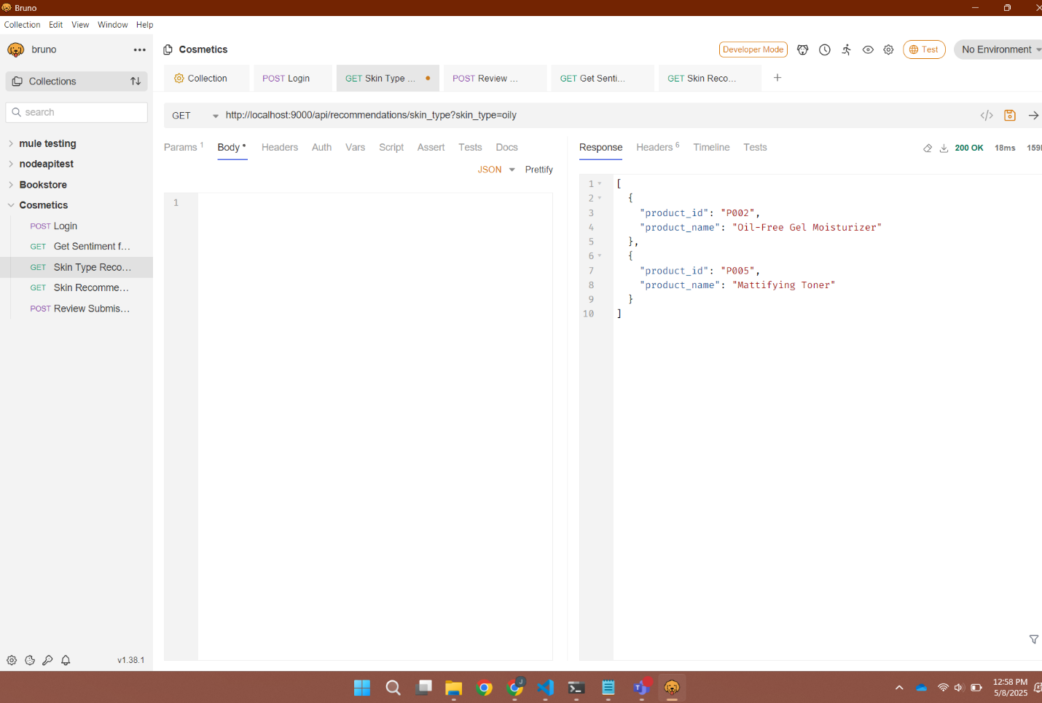

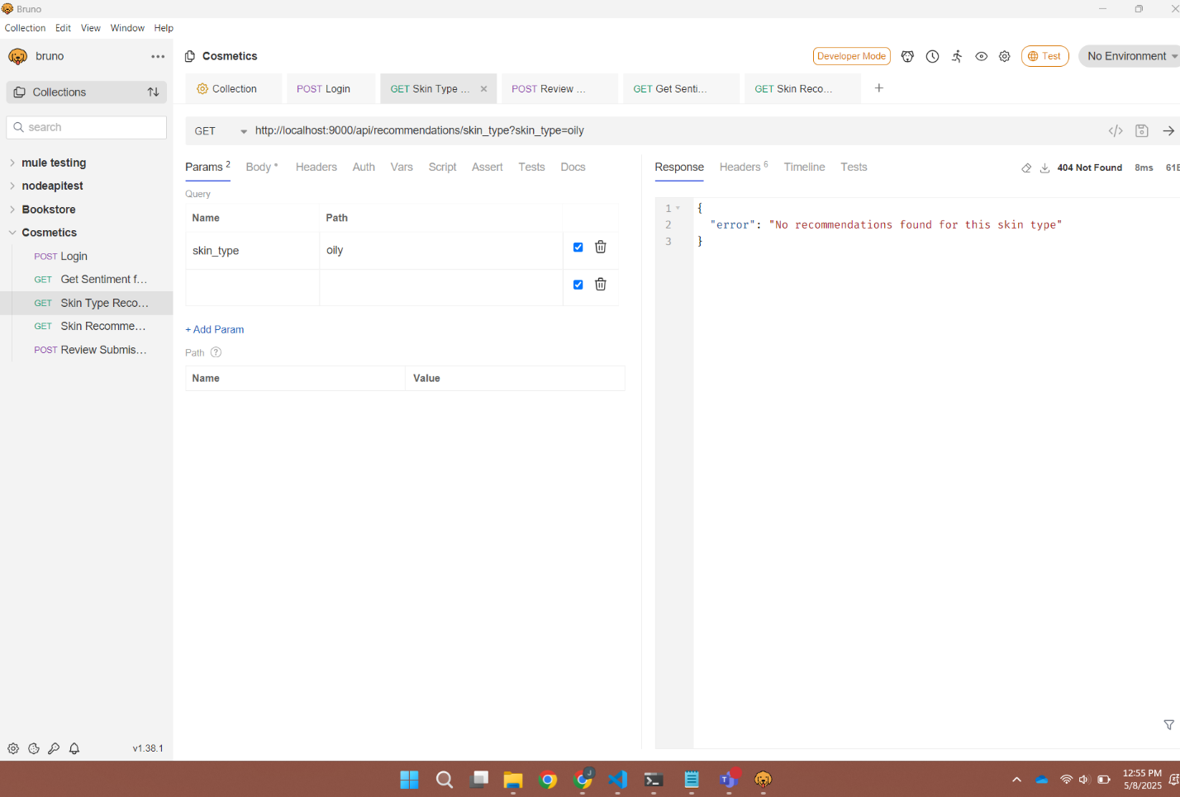

**GET All Products:**

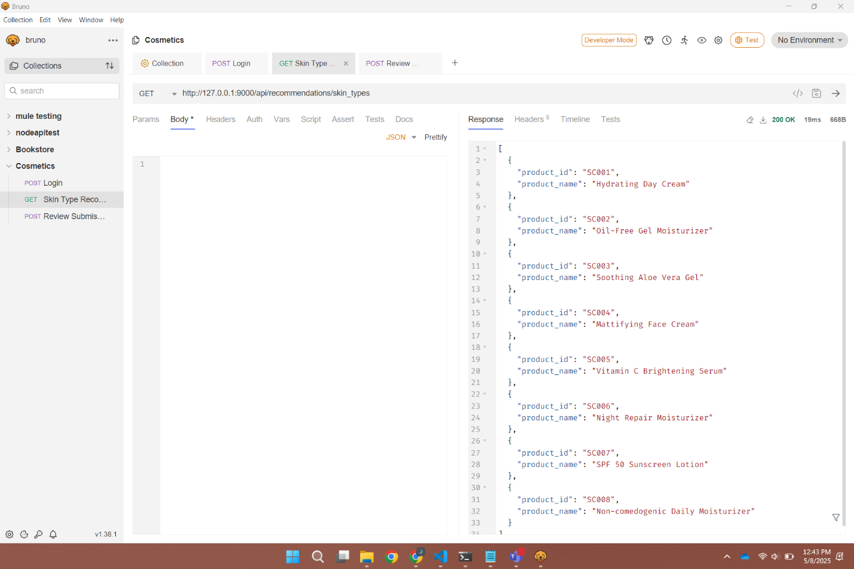

**Review Submission:**

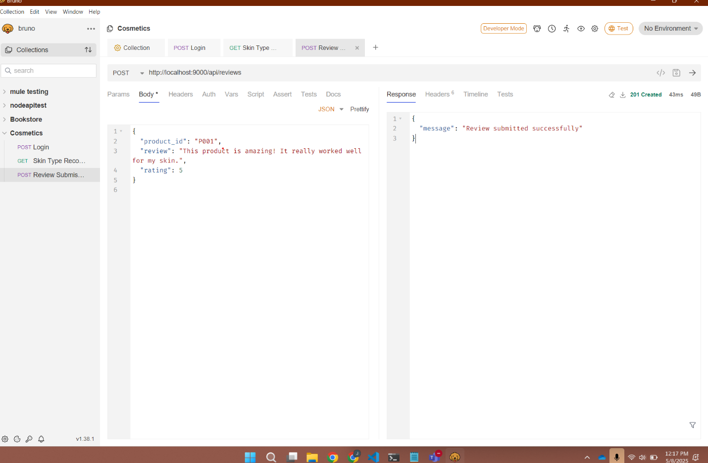

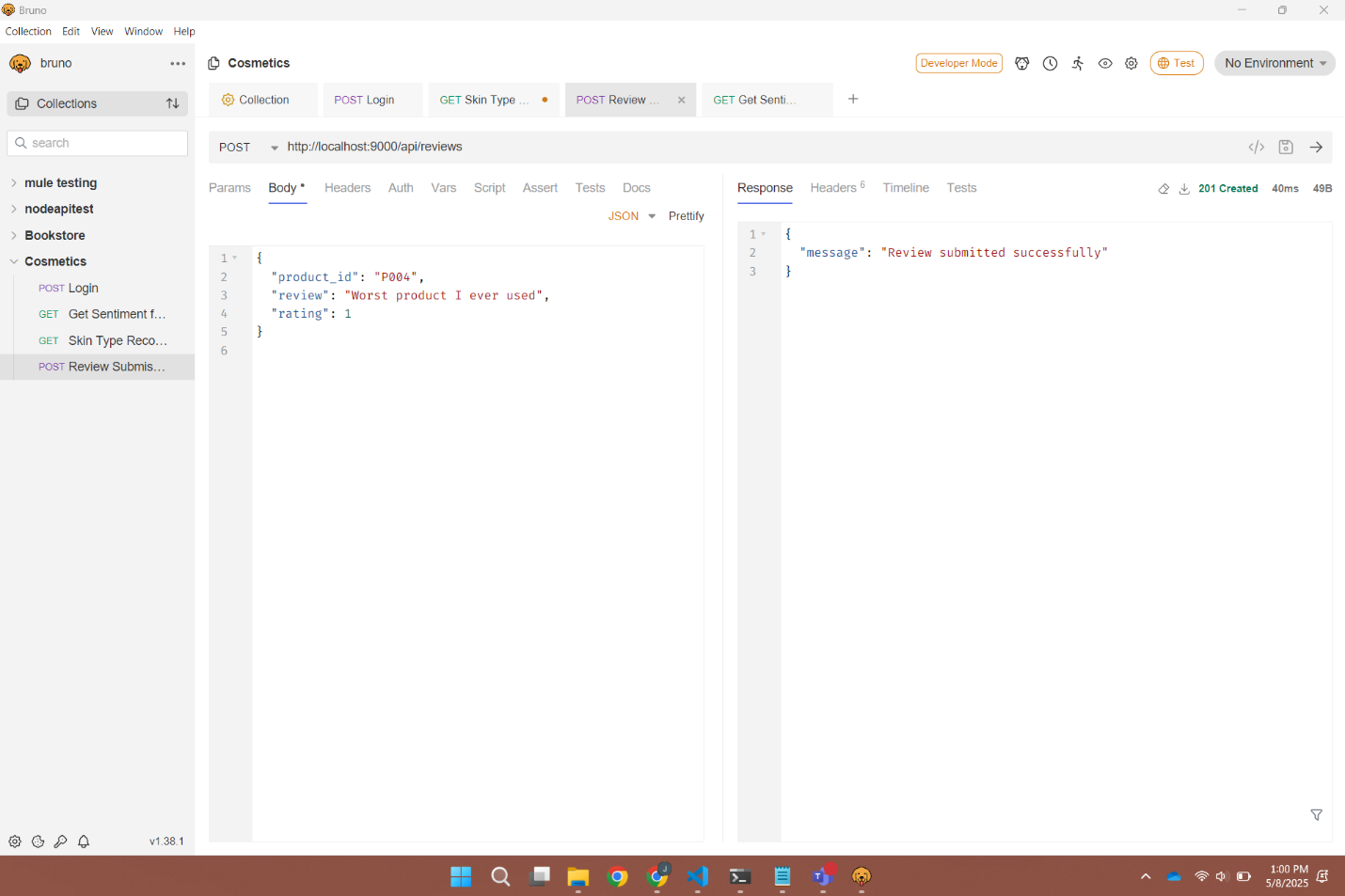

**Sentiment Analysis:**

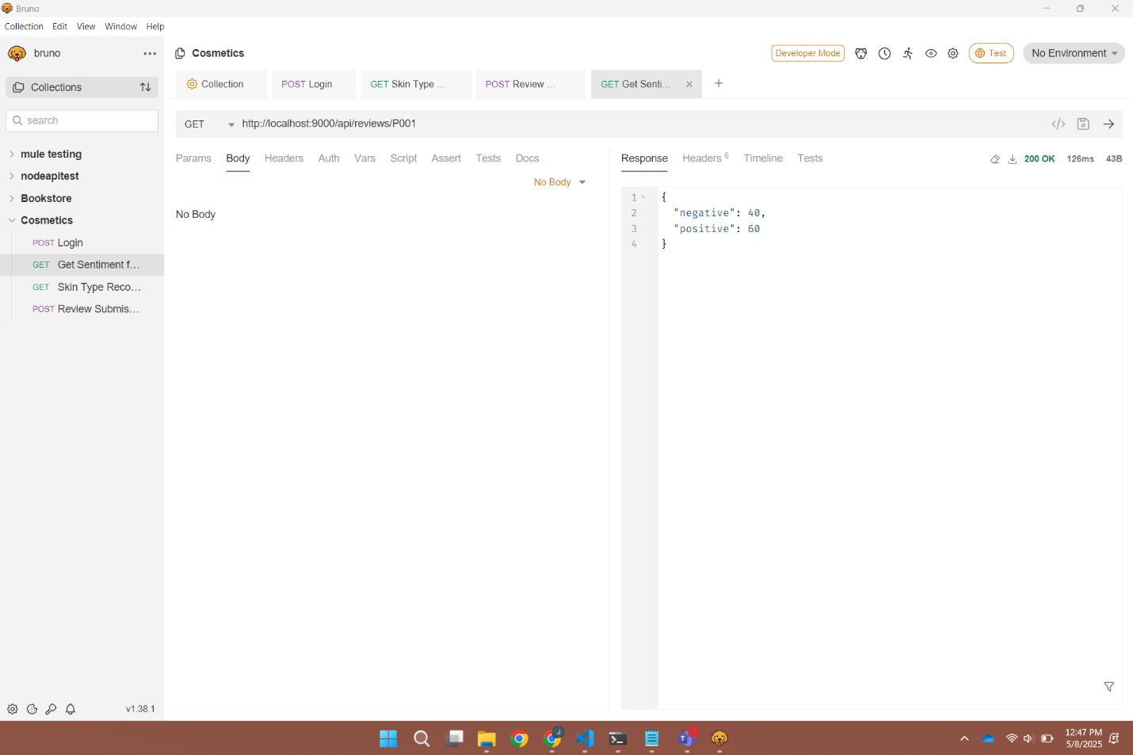

**Login Server Overview**

**Contributor: S Snekha (Backend), Joanisa Hasan (Frontend)**

### **Server Details**

* **Port**: 5050
* **Backend**: Python (Flask)
* **Database**: SQL (with two tables: customers and admins)
* **Authentication**: Email & password-based login
* **Frontend Dashboards**: Separate for customers and admins
* **Session Handling**: Login persists session or token
* **Logout**: Frontend button triggers session/token clearing

## **Database Tables**

### **1. customers**

|  |  |  |
| --- | --- | --- |
| **Column** | **Type** | **Description** |
| id | INTEGER | Primary Key |
| name | TEXT | Customer's full name |
| email | TEXT | Unique email |
| password | TEXT | Hashed password |

### **2. admins**

|  |  |  |
| --- | --- | --- |
| **Column** | **Type** | **Description** |
| id | INTEGER | Primary Key |
| name | TEXT | Admin's full name |
| email | TEXT | Unique email |
| password | TEXT | Hashed password |

## **API Routes**

### **Customer Routes**

#### **1)POST /api/customer_signup**

Registers a new customer.

**Request:**

**{**  
 **"name": "Alice",**  
 **"email": "**[**alice@example.com**](mailto:alice@example.com)**",**  
 **"password": "securepass"**  
**}**

**Response:**

**{ "message": "Customer registered successfully" }**

#### **2)POST /api/customer_login**

Authenticates a customer.

**Request:**

**{**  
 **"email": "**[**alice@example.com**](mailto:alice@example.com)**",**  
 **"password": "securepass"**  
**}**

**Response:**

**{**  
 **"message": "Login successful",**  
 **"dashboard_url": "/customer_home"**  
**}**

### **Admin Routes**

#### **1) POST /api/admin_signup**

Registers a new admin.

**Request:**

**{**  
 **"name": "Admin",**  
 **"email": "**[**admin@example.com**](mailto:admin@example.com)**",**  
 **"password": "adminpass"**  
**}**

#### **2) POST /api/admin_login**

Authenticates an admin.

**Request:**

**{**  
 **"email": "**[**admin@example.com**](mailto:admin@example.com)**",**  
 **"password": "adminpass"**  
**}**

**Response:**

**{**  
 **"message": "Login successful",**  
 **"dashboard_url": "/admin_home"**  
**}**

### **3) GET /api/logout**

Clears session/token on frontend and redirects to login.

**Customer Frontend Routes**

|  |  |
| --- | --- |
| **Route** | **Description** |
| /products | Browse/view makeup products |
| /customer_register | Fill profile details |
| /customer_orders | View customer’s past orders |
| /feedback | Submit product/service feedback |
| /recommendation | AI/ML-based recommendations based on skin type |
| /customer_profile | View & edit profile |
| /logout | Logs out and clears session |

## **Admin Frontend Routes**

|  |  |
| --- | --- |
| **Route** | **Description** |
| /admin | View, update, delete, and manage products |
| /add | Add new product |
| /update/:id | Update product by ID |
| /dashboard | View analytics, feedback stats |
| /logout | Logs out admin and clears session |

# **Output Screenshots:**

# **Error & Exception Handling**

**Contributor: S Snekha**

## **Frontend Error Handling**

### **1. Axios API Error Handling**

All Axios API calls are wrapped in try-catch blocks to gracefully handle network/server errors.

try {  
 const response = await axios.post('/api/customer_login', loginData);  
 // handle success  
} catch (error) {  
 console.error("Login failed:", error.response?.data?.message || error.message);  
 // show user-friendly message  
}

### **2. Error Boundaries in Routes**

React uses Error Boundaries to catch unexpected rendering or route-related issues.

<ErrorBoundary fallback={<Navigate to="/error" />}>  
 <Routes>  
 <Route path="/products" element={<Products />} />  
 ...  
 </Routes>  
</ErrorBoundary>

### **3. Special Routes for Errors**

|  |  |
| --- | --- |
| **Route** | **Purpose** |
| /maintain | Displayed when backend services are under maintenance |
| /error | Global fallback for invalid/unregistered routes |
| /logout | Clears session/token and redirects to login |

## **Backend Exception Handling**

### **API-Level Try/Catch Blocks (Python Example)**

All API endpoints are wrapped in exception handlers to avoid server crashes and send structured error responses.

@app.route('/api/customer_login', methods=['POST'])  
def customer_login():  
 try:  
 data = request.json  
 # validate, check DB, etc.  
 ...  
 return jsonify({"message": "Login successful"}), 200  
  
 except Exception as e:  
 app.logger.exception("Unexpected error during login")  
 return jsonify({"error": "Internal server error"}), 500

**Output Screenshots:**

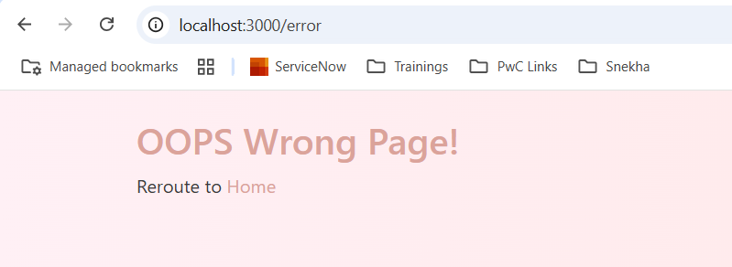

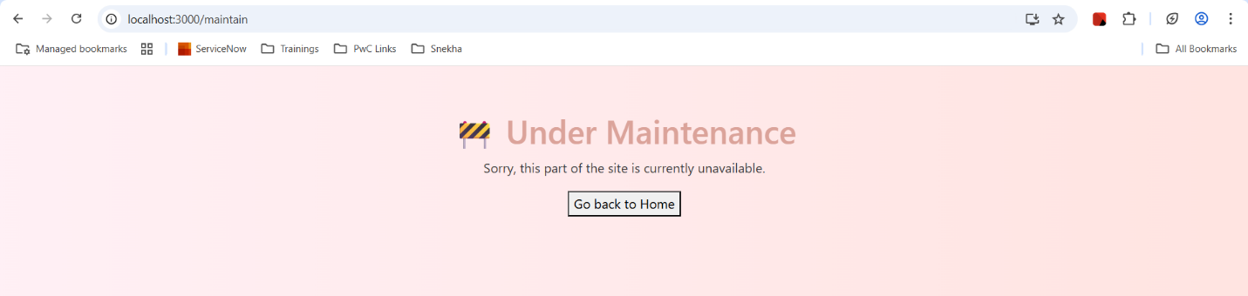

**Eureka Server Documentation**

**Contributor: S Snekha**

## **Overview**

The **Eureka Server** acts as a **service registry** for your microservices-based architecture. It enables **dynamic discovery**and registration of services, allowing seamless communication between distributed services.

**Eureka Server Configuration**

### **Port:** server.port=7070 **Application Name:** spring.application.name=eureka-server **Registered Services**

The following services are registered with Eureka:

|  |  |  |
| --- | --- | --- |
| **Service Name** | **Port** | **Description** |
| **product-service** | 9000 | Manages product CRUD operations |
| **login-service** | 5050 | Customer/Admin authentication service |
| **feedback-service** | 5000 | Collects and manages customer feedback |
| **recommendation-service** | 8080 | Recommends products by skin type |
| **Customer-service** | 5001 | Manages customers and orders |

## **Accessing the Eureka Dashboard**

Once the server is running, visit: [http://localhost:7070/](https://urldefense.com/v3/__http://localhost:7070/__;!!Nyu6ZXf5!pJBz0_4SVHjsmKvJgTzY7-bfZDRpddV6c4Xfq-4cMtitJqVywlgBrv8eVLfx9yU1DlQyBCZWmgGzw1_hRPFH3inU$)This dashboard shows:

* Registered services
* Instance IDs
* Status (UP/DOWN)
* Heartbeat activity

**Logs & Monitoring:** Eureka logs registration, heartbeat failures, and renewals.

**Summary**

* Eureka is running at localhost:7070
* All services register with it via @EnableEurekaClient
* Enables fault tolerance, load balancing, and dynamic service discovery

**Output Screenshot:**

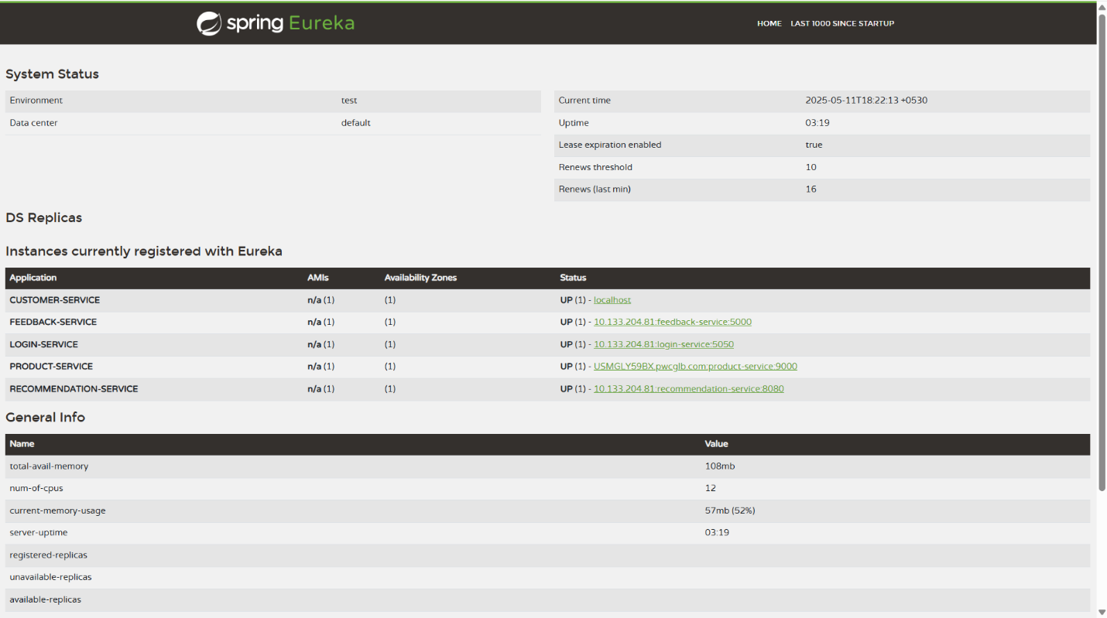

# **Node.js Service Registry Documentation**

## **Contributor: S Snekha**

## **Overview**

## This **Service Registry** acts as a lightweight alternative to Eureka, designed in Node.js. It enables **manual service registration**, **deregistration**, and **discovery** for a microservices architecture.

## **Server Configuration**

* **Port**: 3001
* **Base URL**: [http://localhost:3001](https://urldefense.com/v3/__http://localhost:3001__;!!Nyu6ZXf5!twwIHnEJaXAJUuLNPG409N5LaTfH-ccIOI9e22jJm9FY1tiw3TcBAwEZQDB63DSU-crlPsE9n3AXN6pfcyxzod6e$)

## **API Endpoints**

### **1. POST /register**

Registers a new service.

**Request Body:**

**{**  
 **"name": "service-name",**  
 **"version": "1.0.0",**  
 **"host": "localhost",**  
 **"port": 8080**  
**}**

**Response:**

**{**  
 **"message": "Service registered successfully"**  
**}**

**2. POST /deregister**

Deregisters a service.

**Request Body:**

**{**  
 **"name": "service-name",**  
 **"version": "1.0.0",**  
 **"host": "localhost",**  
 **"port": 8080**  
**}**

**Response:**

**{**  
 **"message": "Service deregistered successfully"**  
**}**

### **3. GET /discover/:name**

Discovers an active service instance by name.

**Example**:

GET /discover/product-service

**Response:**

**{**  
 **"name": "product-service",**  
 **"version": "1.0.0",**  
 **"host": "localhost",**  
 **"port": 8080**  
**}**

### **4. GET /services**

Returns all registered services.

**Response:**

**[**  
 **{**  
 **"name": "product-service",**  
 **"version": "1.0.0",**  
 **"host": "localhost",**  
 **"port": 8080**  
 **},**  
 **{**  
 **"name": "login-service",**  
 **"version": "1.0.0",**  
 **"host": "localhost",**  
 **"port": 5050**  
 **}**  
**]**

**Summary**

|  |  |
| --- | --- |
| **Feature** | **Endpoint** |
| Register | POST /register |
| Deregister | POST /deregister |
| Discover | GET /discover/:name |
| List All | GET /services |
| Port | 3001 |

**Output Screenshots:**

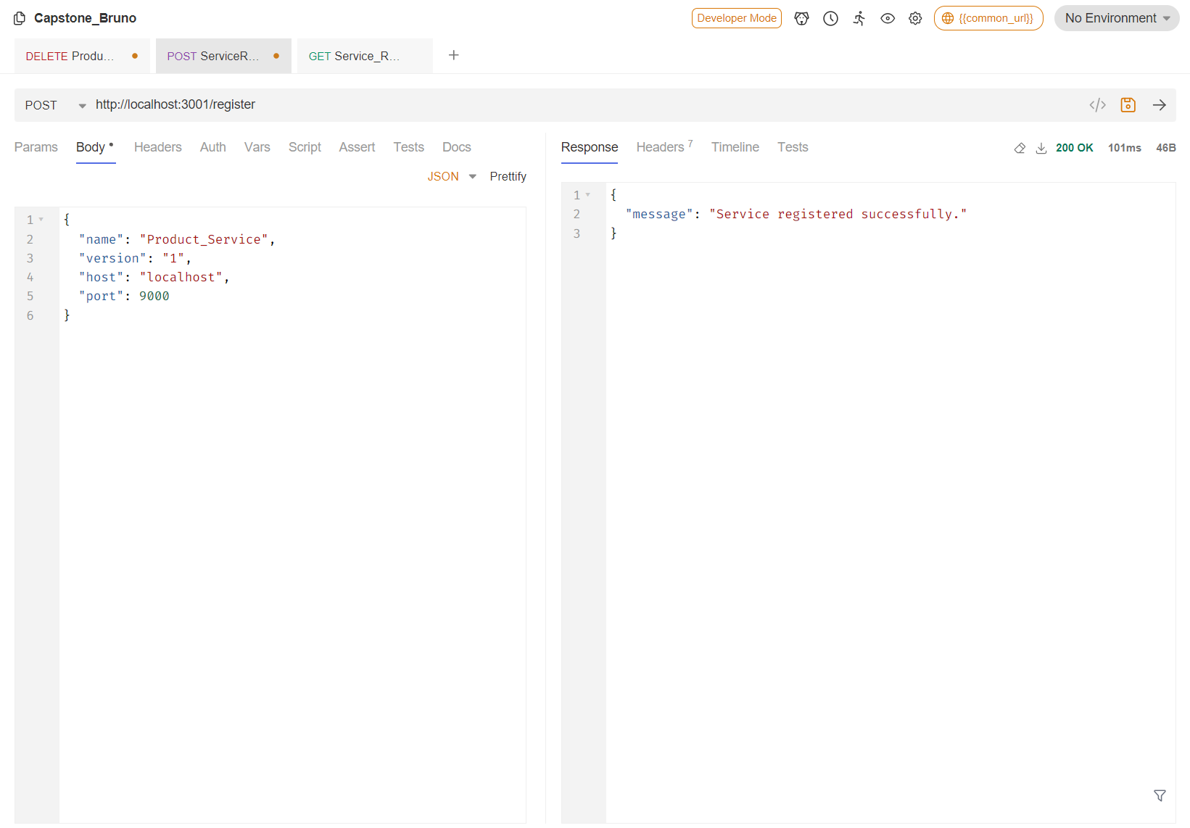

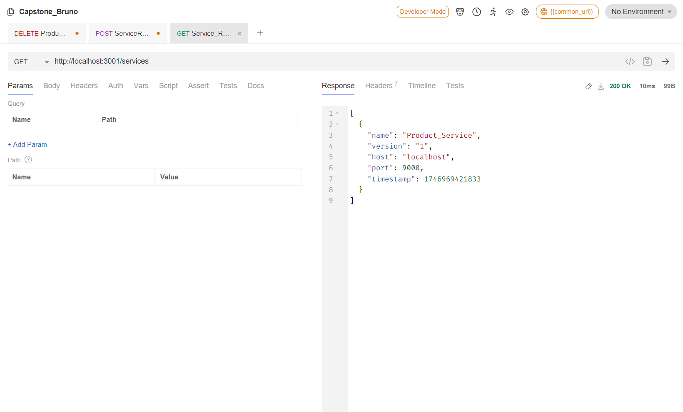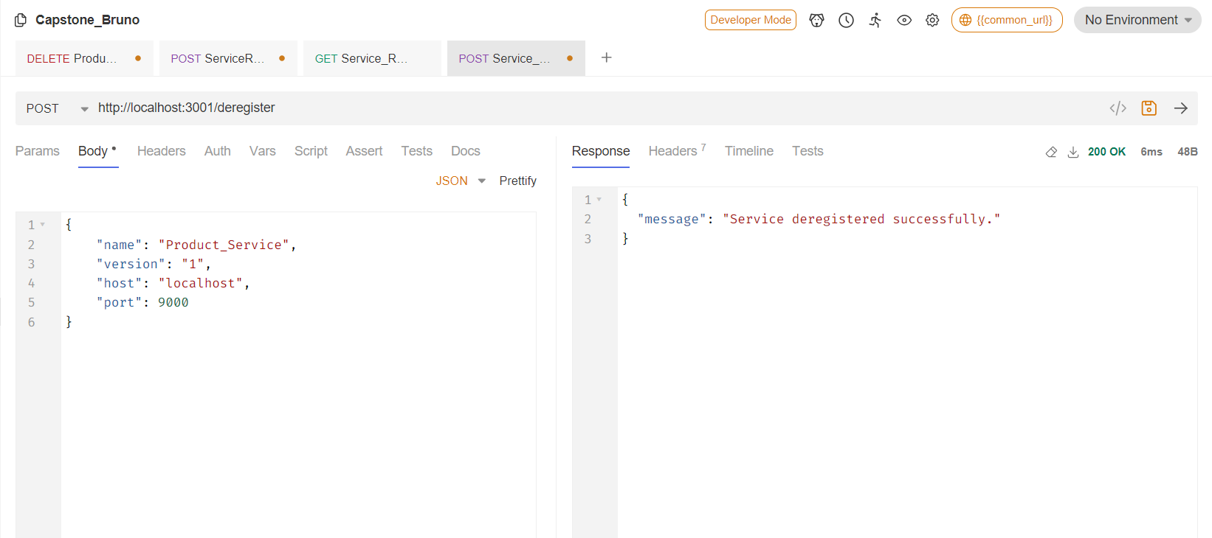

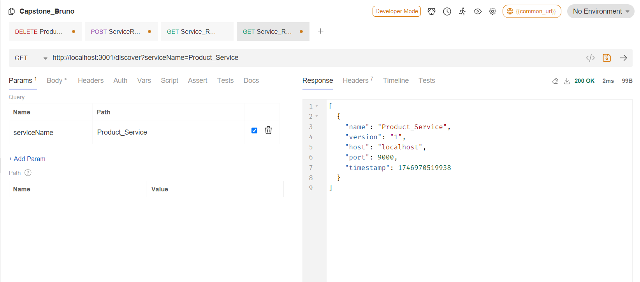

# **Microservices Docker Deployment Documentation**

## **Contributor: S Snekha**

## **Folder Structure**

Each microservice in this architecture includes its own Dockerfile, located in the respective service’s directory.  
**Docker Compose**

### **docker-compose.yml ->** This file orchestrates the build and deployment of all services including:

* Node.js Service Registry
* Eureka Server
* Product Service
* Login Service
* Customer Service
* Recommendation Service
* Feedback Service
* Frontend

Run the entire stack with:

**docker-compose up --build**

This will:

* Build each service using its respective Dockerfile
* Expose the defined ports
* Register services with Eureka or your Node-based service registry
* Handle automatic restarts if containers fail

# **Swagger Documentation Across All Services**

**Contributor: S Snekha**

## **Overview**

## Each microservice in the ecosystem has been integrated with **Swagger UI** to provide interactive API documentation, testing, and easy developer onboarding. This allows users to:

* View all available endpoints
* Understand required request parameters and response formats
* Test APIs directly via browser

## **Set Up**

* **Spring Boot Services**: Use springdoc-openapi-ui dependency for Swagger integration.

**<dependency>**  
 **<groupId>org.springdoc</groupId>**  
 **<artifactId>springdoc-openapi-ui</artifactId>**  
 **<version>1.6.14</version>**  
**</dependency>**

* **Python Services**:
  + **Flask**: Integrated using flasgger or flask-swagger-ui.

## **Benefits**

* **Consistent documentation** across all microservices
* **Easy to test** and debug APIs during development
* **Self-explanatory** for new team members or external consumers
* Ready for **API gateway documentation or aggregation**

# **Inter-Service Communication**

**Contributor: S Snekha**

## **1. Product → Feedback Service (Review Display)**

**Scenario**: When viewing a product details page, user sees feedback for that product.

* **Frontend** fetches product details via the **Product Service** (/api/products/:id).
* Using the product ID from the response, a call is made to the **Feedback Service** (/api/feedback/:productId) to fetch relevant reviews.

**Flow**:

**[Frontend]**  
 **↓ fetch product info**  
**[Product Service - GET /api/products/:id]**  
 **↓ extract product ID**  
**[Feedback Service - GET /api/feedback/:productId]**  
 **→ Returns reviews for that product**

## **2. Product → Customer Service (Order Placement)**

**Scenario**: A customer places an order from the product details page.

* Product info is retrieved from **Product Service**.
* On "Order" click, the frontend sends selected product info + customer ID to **Customer Service** to record the order.

**Flow**:

**[Frontend]**  
 **↓ fetch product info**  
**[Product Service - GET /api/products/:id]**  
 **↓ user clicks 'Order'**  
**[Customer Service - POST /api/customer_orders]**  
 **Body: { customerId, productId, productName, price, quantity }**  
 **→ Adds order under customer's record**

**3. Kafka-Based Communication**

**Purpose**: Notify dependent services (e.g., Feedback and Customer) about new product additions.

### **📤 Kafka Producer: Product Service**

* When a new product is added via /api/products/add, it:
  + Adds the product to the DB
  + Sends a Kafka message to the topic new-products with full product JSON

# Kafka message sent from Product Service (Producer)  
**{**  
 **"id": "p101",**  
 **"name": "Lipstick",**  
 **"price": 299,**  
 **"category": "Makeup",**  
 **"description": "...",**  
 **...**  
**}**

### **📥 Kafka Consumers:**

#### **a) Customer Service (Node.js)**

* Listens to new-products topic.

#### **b) Feedback Service (Python)**

* Listens to the same new-products topic.

**Architecture**:

**[Product Service]**  
 **→ Kafka Producer: topic "new-products"**  
 **↓**  
 **[Customer Service (Consumer)] → Logs new product / updates view**  
 **[Feedback Service (Consumer)] → Prepares review section / initializes data**

**Output Screenshots:**

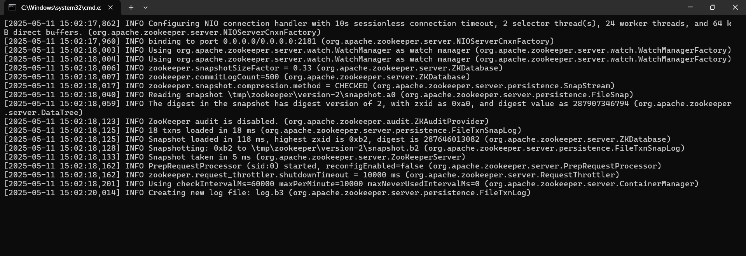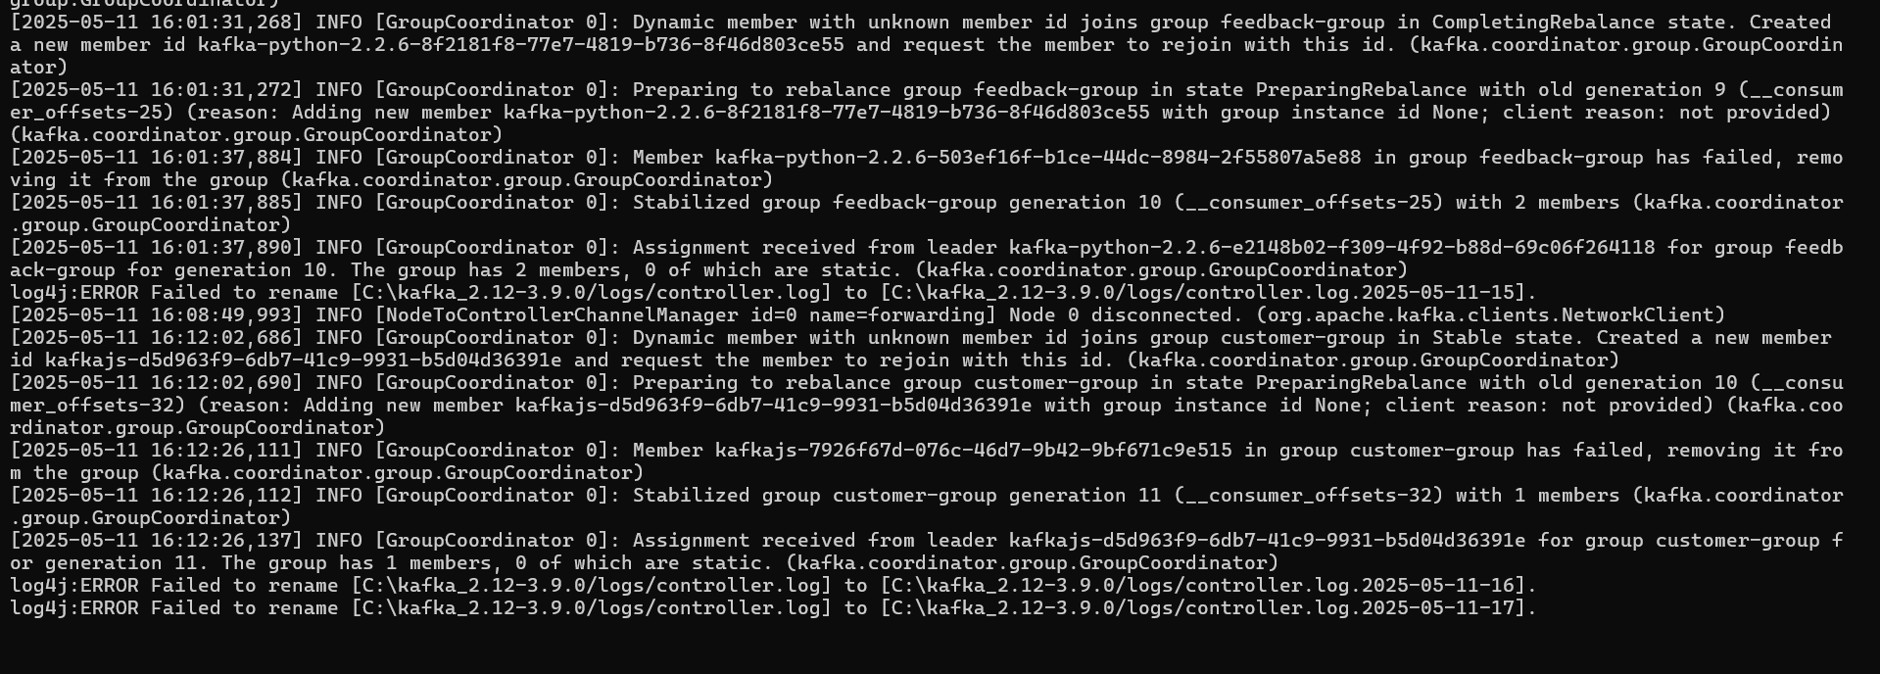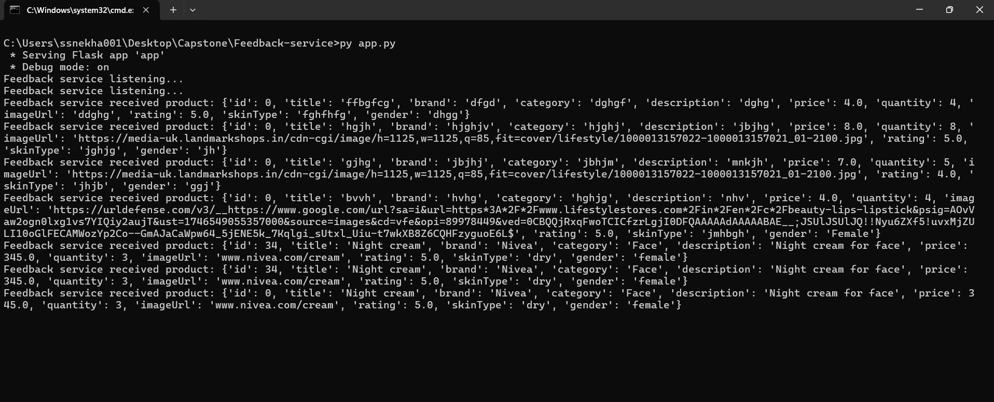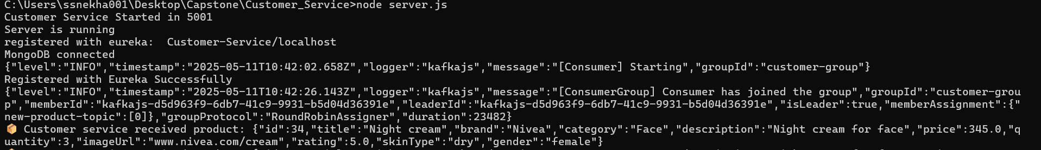

**Conclusion:**

The **Cosmetics Store Microservices Platform** is a full-stack e-commerce solution designed to manage makeup product listings, customer orders, feedback, and administrative operations with a lot of microservices integrated inside to provide a seamless customer experience.